DOCUMENT MANAGEMENT SYSTEM

DMACQ SOFTWARE PRIVATE LIMITED

SUBMITTED IN FULLFILLMENT OF THE REQUIREMENT IN THE DEGREE,

**MASTER OF COMPUTER APPLICATIONS**

**UNDER THE GUIDANCE OF**

**PROF: RASIKA MALLYA**

**DEPARTMENT OF MASTER OF COMPUTER APPLICATIONS**

**NAVINCHANDRA MEHTA INSTITUTE OF TECHNOLOGY AND DEVELOPMENT**

**UNIVERSITY OF MUMBAI**

**ACADEMIC YEAR 2014 - 2015**

DOCUMENT MANAGEMENT SYSTEM

Undertaken for dMACQ Software Private Limited



FINAL YEAR, MASTER OF COMPUTER APPLICATIONS (M.C.A)

PROJECT REPORT AND BLACK BOOK FOR THE ACADEMIC YEAR 2014 - 15

Zubin Kadva

Arehman Jamal

Iyer Rahul Rajan

**ACKNOWLEDGEMENT**

One of the great pleasures of writing this project book is acknowledging the efforts of many people whose names may not appear on the cover but whose hard work and cooperation has led to the completion of the project titled - “DOCUMENT MANAGEMENT SYSTEM”.

We are very much thankful to our mentor Mrs. Rasika Mallya and our institute director Dr. Seema Purohit who were kind enough to give us an opportunity to do this project work.

Being our guide she imparted us immense administration knowledge and provided us with a clear background about the problem scenario which helped us in laying a strong foundation of our project.

It gives us pleasure in presenting this project book whose justification will never sound good if we do not impress our vote of thanks to all our staff members of the MCA department of our college for allowing us to work in the lab, without whose help our project and its thesis would have neither begun nicely nor would have had reached the best ending.

We are much thankful to our project guide and all other teaching and non-teaching staff for their suggestion, reviews, encouraging criticism and time to time help and support which led us to achieve our goals and overcome the difficulties.

***Last but not the least we are thankful to our parents & friends who gave us the much needed moral support & encouragement which made developing this project a work of sheer joy & satisfaction. Thank you all once again.***

**LIST OF ACRONYMS AND THEIR EXPANDED FORMS:**

|  |  |  |
| --- | --- | --- |
| Sr. No. | Acronym | Meaning |
| 1 | PHP | Hypertext pre-processor |
| 2 | XML | Extensible Markup Language |
| 3 | AJAX | Asynchronous JavaScript and XML |
| 4 | HCI | Human Computer Interface |
| 5 | HTML5 | Hypertext Markup Language v5 |
| 6 | MySQL | My Structured Query Language |
| 7 | DMS | Document Management System |
| 8 | FOSS | Free and Open Source Software |
| 9 | ROM | Read Only Memory |
| 10 | RAM | Random Access Memory |
| 11 | OTA | Over The Air |
| 12 | OCR | Optical Character Recognition |
| 13 | FMT | File Movement Tracker |

**LIST OF FIGURES:**

Figure 3.1 - Project Development Gantt Chart 6

Figure 4.1.1 – Use Case 7

Figure 4.2.1 - Document and Index Group 8

Figure 4.3.1 - Bulk Mail 9

Figure 4.3.2 – Help 10

Figure 4.3.3 - Remote File Storage (DFS) 11

Figure 4.4.1 - Basic Operations 12

Figure 4.4.2 - Bulk Mail 13

Figure 4.4.3 – Help 14

Figure 4.4.4 - File Movement Tracker 14

Figure 4.5.1 - FMT Class Diagram 15

Figure 4.6.1 - FMT Sequence Diagram 16

**LIST OF TABLES:**

Table 5.1 - Page 18

Table 5.2 - Project Documents 19

Table 5.3 - Categories 20

Table 5.4 - OCR Queue 20

Table 5.5 - Mod Mail Outbox 20

Table 5.6 - Bulk Email Queue 21

Table 5.7 – Reports 21

Table 5.8 – Help Search 21

Table 5.9 – FMT Doc In 22

Table 5.10 – FMT Doc Log 23

Table 5.11 – FMT Doc Out 23

Table 5.12 – FMT Files Details 24

Table 5.13 – FMT Files Trash 24

Table 5.14 – FMT Request 25

Table 5.15 – Doc Index Fields 25

Table 5.16 – Doc Index Values 26

Table 5.17 – Doc Index Group 26

Table 5.18 - Proposal Master 27

Table 5.19 - Proposal Other Details 27

Table 5.20 - Proposal Tax Details 27

Table 5.21 - Proposal Files 28

Table 5.22 - Invoice Master 28

Table 5.23 - Invoice Other Details 29

Table 5.24 - Invoice Tax Details 29

Table 5.25 - Invoice Files 29

Table 5.26 - Invoice Collection Details 30

**EXECUTIVE SUMMARY OF THE PROJECT**

*Project Definition*

**Online Document Management System**

*Why this topic is chosen?*

This project implements a Document Management System (DMS) using a user-centred design approach. The basic problem in majority of corporations is that they are not realizing efficiencies that would result from better applications of technology in their daily operations. They are faced with difficulties such as management of their official documents, keeping track of them and various other hindrances.

Thus, we present an efficient means to perform all the required policies through the “Online DMS”.

*Scope & Objective*

A user-centred design is considered. The goal is to create a very usable and user friendly service that can be run on the World Wide Web to allow proper management of their daily documents and information such that they need not worry about the hassles of stuff being misplaced or things that have been forgotten. Corporations can highly benefit from this project.

**The following are the objectives of this project:**

To easen the document management process.

To present a customizable and easy-to-understand user interface.

To extend the system functionality beyond the scope of documents.

To make the system as secure and robust as possible.

It has been designed to meet all the requirements from different types of users.

*Methodology to be adopted*

This project has been implemented using the Hypertext Pre-processor **(PHP)** technology for developing interactive web sites, **JQuery** and Asynchronous JavaScript and XML **(AJAX)** for scripting support. Human-Computer Interaction, Hypertext Mark-up Language **(HTML5)**, Apache Tomcat, PHP and **MySQL** Database are used as implementation technologies.

*Software / Hardware Requirements*

A functional and robust web browser.

Table of Contents

1. INTRODUCTION 1

1.1 Company Profile 1

1.2 Legacy System 1

1.3 The Existing System 2

1.4 The Proposed System 2

2. OBJECTIVES 4

2.1 Product Perspective 4

2.2 User Interface 4

2.3 Hardware Interface 4

2.4 Software Interface 5

3. GANTT CHART 6

4. ANALYSIS AND DESIGN 7

4.1. Use Case Diagram 7

4.2. Activity Diagrams 8

4.3. Entity Relationship Diagrams (Module wise) 9

4.4. Flowcharts (Module wise) 12

5. DATA DICTIONARY 15

6. SCREENSHOTS 31

6.1. Basic Operations 31

6.2. The Bulk Mail System 33

6.3. The Distributed File System 36

6.4. The OCR Queue 38

6.5. The interactive in-application help system 40

6.6. File Movement Tracker (FMT) 43

6.7. Advanced Search 50

6.8. Expert Search 51

6.9. Proposals 53

6.10. Sales Invoice 55

7. CONCLUSION 59

8. FUTURE ENHANCEMENT 60

9. REFERENCES 61

10. BIBLIOGRAPHY 62

# INTRODUCTION

## 1.1 Company Profile

DMACQ is a team of energetic and experienced professionals, engaged in designing, developing and deploying software enterprise solutions and digitization solutions both as product and service. Driven by innovative ideas and thorough understanding of the enterprise requirements we have built ‘Software as a Service’ (SaaS) based applications which are hassle free and user friendly. Our product and services help enterprises manage their resources more effectively and efficiently to gain proven advantages in terms of cost, time, utility and quality by centralizing an Organization’s multi location & departments, thus adding value to their business. Our Industry-neutral and web based modules work across various Business Verticals with standard and popular platform and technologies to provide reliable, secure and cost-effective IT service solutions.

With 9 strategically located centres, we are eager to evolve into an instrumental player in the industry, our solutions, product and supportive services are based on our collective knowledge, experience and expertise on domains and technologies. We strongly believe that accurate integration of processes and technologies will deliver value to the enterprise.

## 1.2 Legacy System

These days, a lot of company documents are stored on computers and servers which can be easily accessible to users at any place as long as they get permission to view the documents. Companies use these documents in a number of ways: to simply store them at one location, to train users, or to maintain training documents and logs.

At dMACQ Software Pvt. Ltd., the same need has come along since the plans for expansion came into being. This needled to developing a Document Management System which can be used to store the company’s policy documents for the standard operating procedure used to train employees and to reduce the paperwork that needs to be maintained.

## 1.3 The Existing System

Most companies are faced with the mind boggling task of maintaining a log of all the documents coming in and going out of the organization. Up until now, companies use to maintain physical or in some cases virtual copies of documents required. Depending on the need of the company, additional registers were maintained as log records. As the organization and the number of employees grew, there has been an increasing need for an efficient means to keep track of these documents.

Furthermore, strenuous security measures have further toughened the task of document management.

Maintaining such documents as manual paper work can result in reduce performance and even lead to errors. Hence a need for a system that can be used for storing such documents and can also be used for assigning tasks to users for making revisions to such documents arise.

## 1.4 The Proposed System

The proposed system is the package developed using high level advanced programming techniques such as PHP, Perl, HTML5, AJAX, JQuery, and other FOSS systems.

*The front-end is PHP / JavaScript and all data is stored in the database.*

*The back-end is MySQL.*

Physical storage of the documents are stored within the file system *(or remotely)*. Taking into consideration, the need for increasing security, the documents are stored in encrypted compressed fashion and thus are only viewable and manipulated through the application.

The system also supports advanced document management techniques using FOSS from other document management systems. Other additional features can be found in the later part of the document.

*Following are the advantages of the proposed system:*

* Data is in an organized manner.
* Saves lots of humane power, thus money.
* As compared to register lockers a computer requires a considerably small amount of space.
* It is very easy to store and transfer data through computer peripherals like CD-ROMs / Flash Drives / OTA.
* Real-Time data is logged along with real time plotting of reports.
* Already recorded data can also be viewed in the form of reports and data.
* The storage provided by the computer is enormously larger as compared to registers.
* Data accuracy is highly guaranteed in real-time situation.

# OBJECTIVES

This chapter gives the overall description of the Document Management System. Then, we address the specific product requirements.

## 2.1 Product Perspective

The Document Management System is a web-based system and can be accessed using:

Internet Explorer 9.X and above, Mozilla Firefox 37.X an above, and Google Chrome 40.X and above.

## 2.2 User Interface

The two interface types in the Document Management System are as follows:

*1. User Interface*: Users shall be able to view the tasks assigned to them and to upload the new/revised documents to the system and other actions as per company policies.

*2. Admin Interface*: The Admin shall be able to assign tasks to users for creating new documents/making changes to revised documents, approving/rejecting the new/changed documents, and viewing the detail summary for each document history.

## 2.3 Hardware Interface

The Document Management System shall provide minimum hardware requirements. The following hardware configurations are required for a PC using the Document Management System:

Pentium processor

256 MB of free hard-drive space (may increase as per number of documents)

1024 MB of RAM (or more for faster operation)

Scanner

10 Mbps or higher LAN (for remote storage)

## 2.4 Software Interface

This section lists the requirements of the system that would be needed to run the Document Management System efficiently.

It would list the Operating System required that would allow the system to run effectively, the interface that would be required to run the application, the driver required for running .NET web applications and the third party tool that would be used for editing purposes.

*Operating System*: Windows (Windows 7 / 8 / Server 2008) or Linux (Ubuntu, Redhat, Cent OS) or Mac OS X 10.8 or later

*Server support*: Curl, Open SSL, Mcrypt, File Info, Cron Jobs

*FOSS*: ImageMagik, Tesseract OCR, IMAP, PDFTK, GhostScript

# GANTT CHART

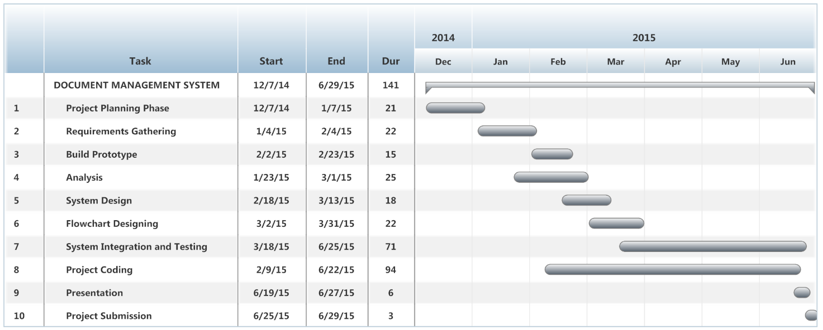

Figure 3. - Project Development Gantt Chart

# ANALYSIS AND DESIGN

## Use Case Diagram

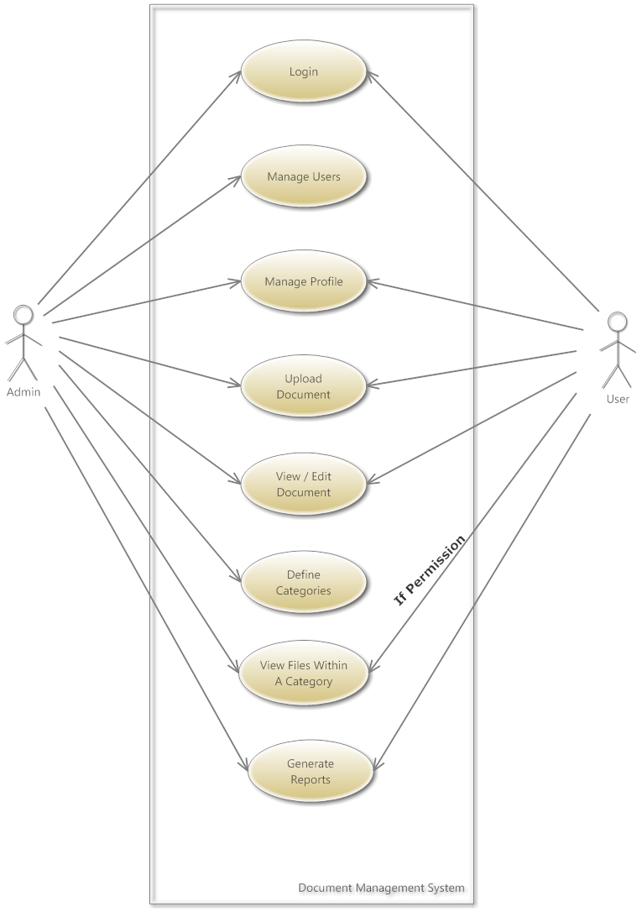

Figure . – Use Case

## Activity Diagrams

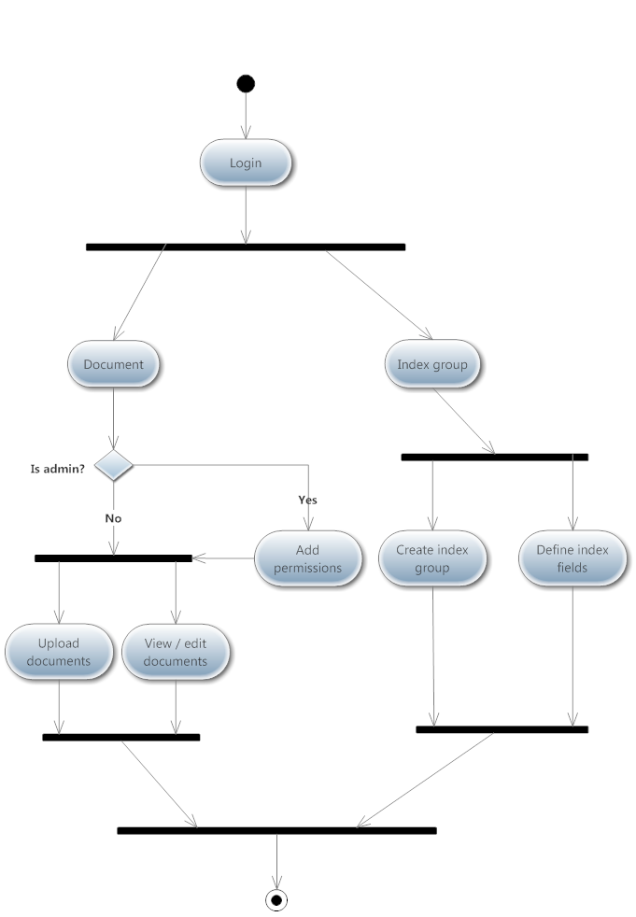

Figure . - Document and Index Group

## Entity Relationship Diagrams (Module wise)

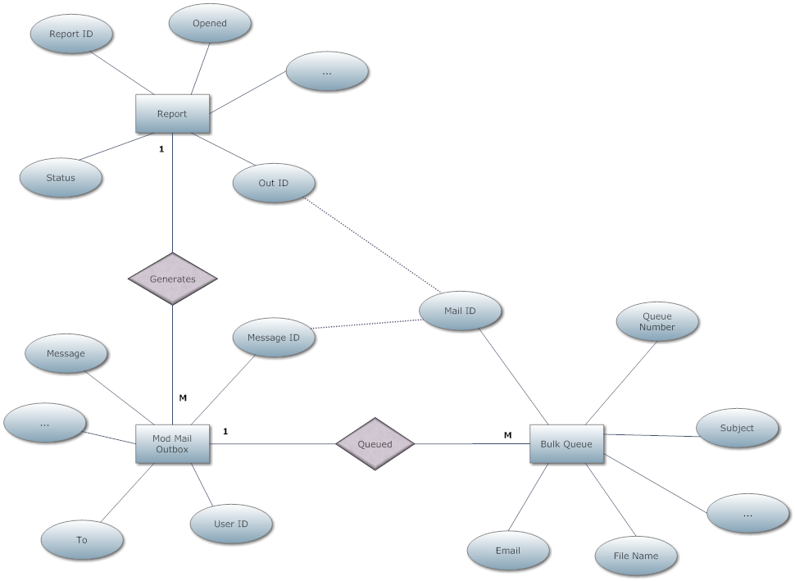

Figure . - Bulk Mail

Description:

The bulk mail becomes a sensible decision when there are hundreds or even thousands of customers. A user can simply go into the “marketing addresses” section, where he can select a category or manually tick the ones to whom the mail is to be sent.

After the selection has been made, the user is to compose the actual contents of the mail. Following which, the user simply clicks “Send”.

The system queues these messages in a bulk queue. It makes use of a “Cron Job” to monitor the queue at every minute. Once triggered, it scans the queue for entries and processes (sends mail) them.

If no entries are found, the job simply continues to wait till the next minute.

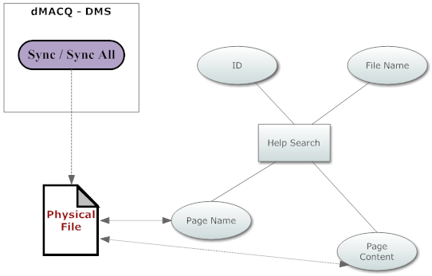

Figure . – Help

Description:

Help is a section which provides assistance to users to learn how to perform a specific operation. To access this menu, the user has to simply click on the question mark icon on the top right corner, next to the lock icon.

On the left, the user is presented with master titles or headings which may be further categorized into sub headings, similar to the structure of a typical index.

However, in a paper index, it may not be possible to search for content. That is where the search feature provided here becomes useful. However, things may not work out if the content of a page responsible for the help content changes. In such cases, the super admin, makes use of the “Sync” feature that synchronizes content of individual pages with the database. The system also presents a “Sync All” feature that synchronizes content of all pages with the database.

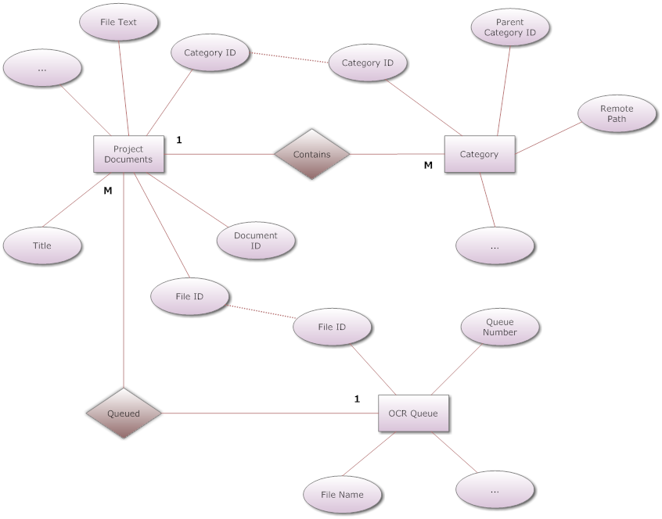

Figure . - Remote File Storage (DFS)

Description:

Distributed File System (DFS), is used to store documents remotely and not on the physical location where the application is currently running, also known as the local system.

In this case, the system recognizes if the selected category is a remote category and has a ‘remote path’. After that, the document is stored in the remote location and can be managed as easily as a local file.

Currently, this feature runs only on Windows Operating Systems, but in the near future, may be developed to make it OS independent.

## Flowcharts (Module wise)

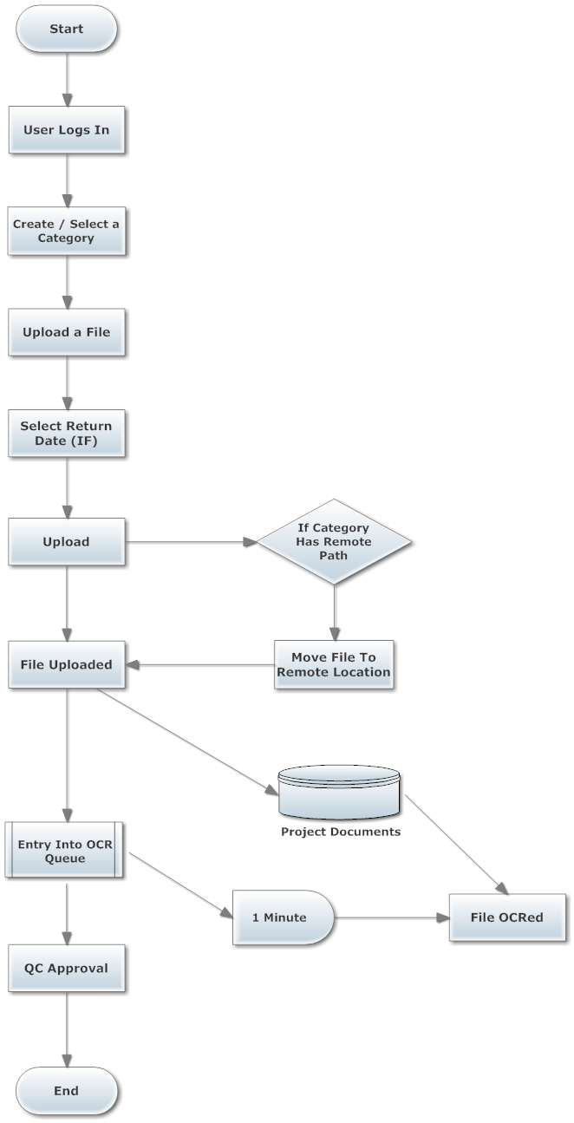

Figure . - Basic Operations

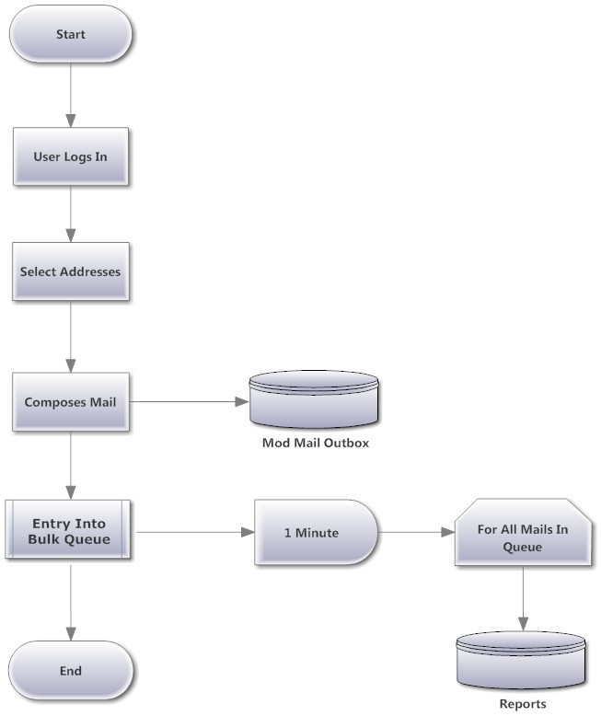

Figure . - Bulk Mail

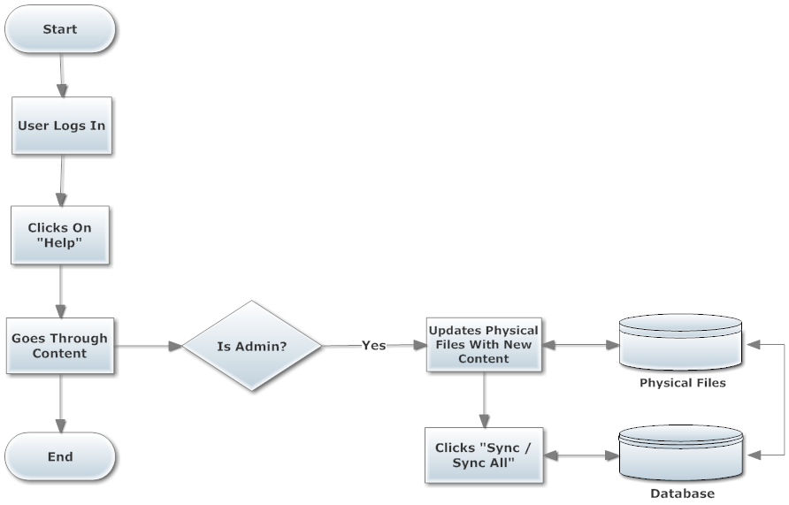

Figure . – Help

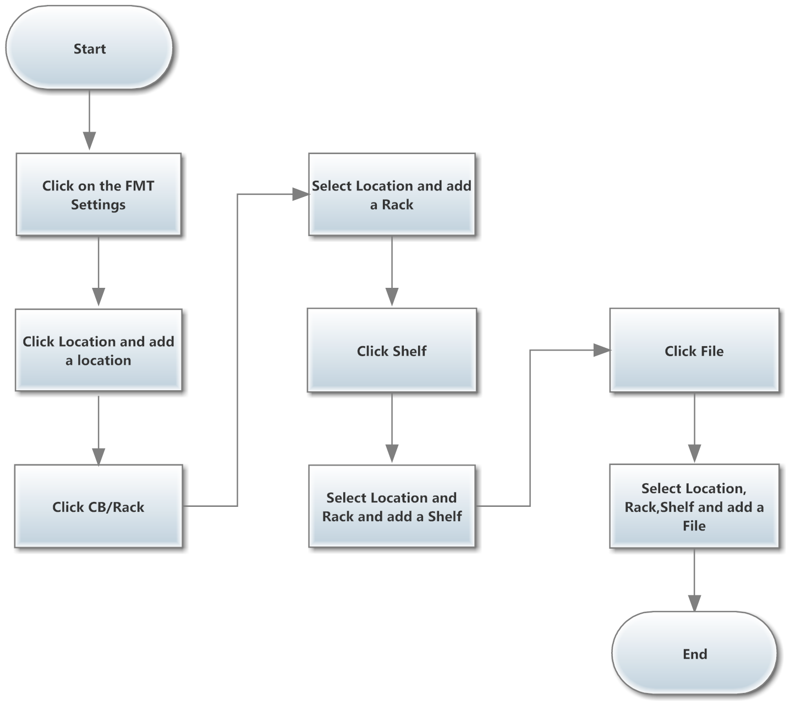

Figure . - File Movement Tracker

## Class Diagram

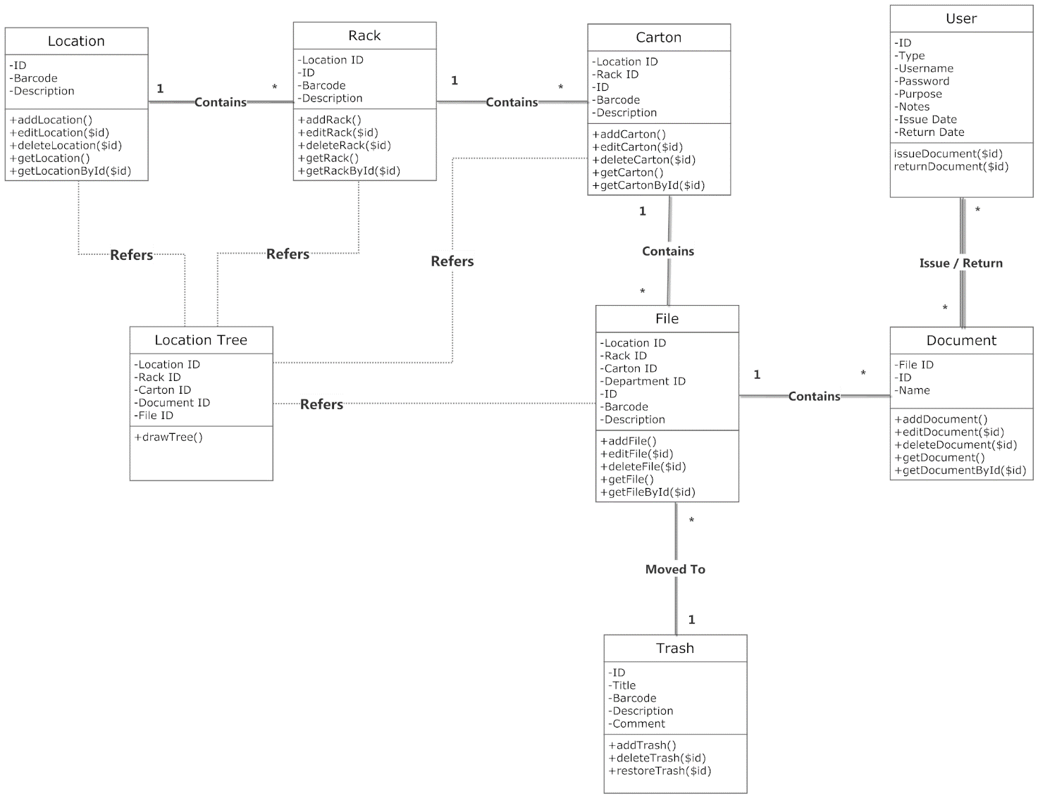

Figure . - FMT Class Diagram

## Sequence Diagram

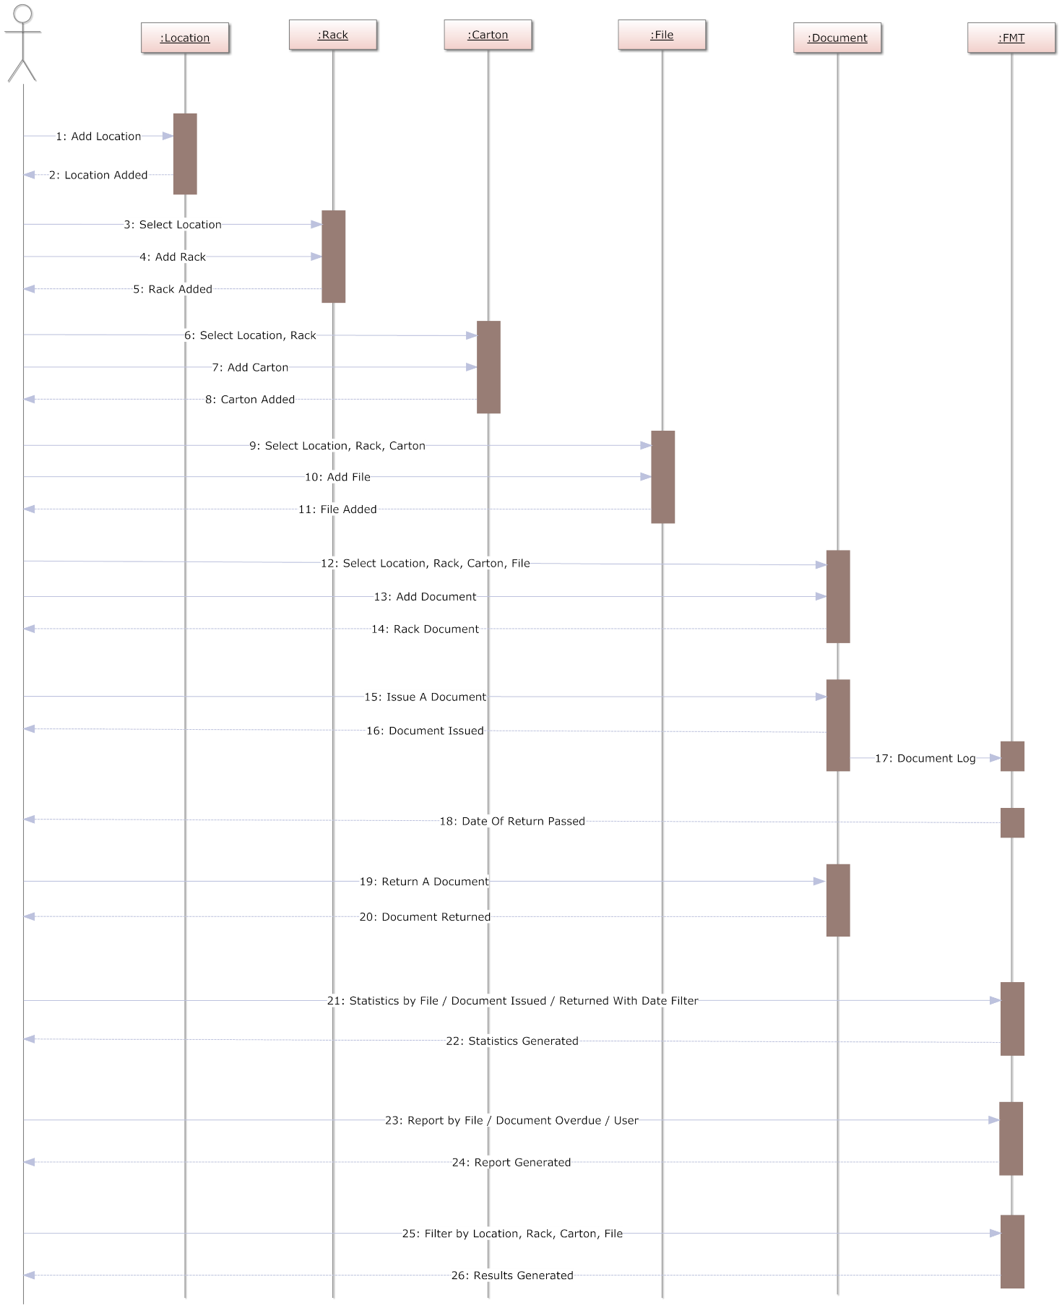

Figure . - FMT Sequence Diagram

*File Movement Tracker (FMT): Scenario*

Persona: John

User Group: FMT Admin

The FMT system, is useful for managing the physical movement of a document.

It follows the structure:

LOCATION 🡪 RACK 🡪CARTON 🡪 FILE 🡪 DOCUMENTS

John starts by creating a location by entering its ID, barcode, description.

He creates a rack by selecting a location and entering its ID, barcode, description.

He then creates a carton by selecting a location, rack and entering its barcode, description.

Ultimately he creates a file by selecting a location, rack, carton and entering its ID, barcode, description and department.

Finally, he creates a document by entering its name, notes and selecting a file.

John, can see that below each creation form is a details form showing all the locations / racks / cartons / files as per his selection.

On the main FMT dashboard, there is a tabular representation of the files and documents which are issued.

John wants to issue a document. So he enters the location tree and traverses through the tree to find the document. Clicking the document opens a page where he must enter the user to whom it is issued along with its purpose, notes and the intended return date. The document is issued.

When the time comes for returning the document, the assigned user clicks on the return button, enters notes and returns it.

Suppose, the document is not returned at the due date, a badge “O” appears next to the due date.

John can filter documents or even files that have been issued / returned.

John can also generate reports with these filters applied

John’s work is done here and thus logs out of the system.

# DATA DICTIONARY

The dMACQ DMS consists of a vast number of tables. Since it is not possible to describe all of them, subject to time and space constraints, we describe only some of the relevant tables only.

|  |  |  |
| --- | --- | --- |
| Column | Data type | Description |
| id | int(11) A/I | Unique ID |
| parent_id | int(11) | Parent ID |
| page_name | varchar(50) | Page Name |
| page_description | text | Page Description |
| link | varchar(155) | Link URL |
| type | int(11) | Type |
| type_mod | varchar(255) | Module Type |
| active | enum('Y', 'N') | Is Active / Inactive |
| mail_send | enum('Y', 'N') | Send Mail |
| menu_icon | varchar(255) | Icon |
| sorting_order | int(11) | Sorting |
| group | varchar(50) | Group |
| menu_status | tinyint(4) | Status |

Table . - Page

|  |  |  |
| --- | --- | --- |
| Column | Data type | Description |
| id | int(11) | Unique ID |
| doc_id | varchar(255) | Document ID |
| parent_id | bigint(20) | Parent ID |
| file_id | bigint(20) | File ID |
| project_id | int(11) | Project ID |
| user_id | int(11) | User ID |
| category_id | text | Category ID |
| categories_tag | varchar(255) | Category Tags |
| keywords | text | Keywords |
| notes | text | Notes |
| title | varchar(255) | File Title |
| file_name | varchar(255) | File Name |
| thumbnail | varchar(255) | File Thumbnail |
| file_type | varchar(255) | File MIME |
| file_size | float(200,0) | File Size |
| file_txt | longtext | File OCR |
| flag | text | Flag |
| stage | varchar(200) | Stage |
| download | varchar(1000) | Download |
| qa_link | tinyint(4) | Link |
| tags | text | Tags |
| status | varchar(50) | Status |
| lock_status | smallint(2) | Is Locked |
| locked_by | bigint(20) | Locked By |
| show_on_dash | smallint(2) | Active / Inactive |
| doc_link | varchar(500) | Document Link |
| dod | date | Date Of Due |
| doc_type | varchar(300) | Document Type |
| emp_type | int(100) | Employee Type |
| emp_id | varchar(250) | Employee ID |
| hash_key | varchar(500) | Hash Key |
| field_conntent_status | int(10) | File Fields |
| log_datetime | timestamp | Log |
| file_key | varchar(255) | File Key |
| new_title | varchar(255) | File New Title |

Table . - Project Documents

|  |  |  |
| --- | --- | --- |
| Column | Data type | Description |
| id | int(11) | Unique ID |
| module | varchar(50) | Module Name |
| user_id | bigint(20) | User ID |
| a_users | text | Assigned Users |
| parent_id | int(11) | Parent ID |
| category | varchar(100) | Category Name |
| tags | text | Category Tags |
| status | tinyint(4) | Status |
| log_datetime | datetime | Log |
| remote_path | varchar(100) | Remote Path |

Table . - Categories

|  |  |  |
| --- | --- | --- |
| Column | Data type | Description |
| id | int(11) | Unique ID |
| file_id | int(11) | File ID |
| file_name | varchar(500) | File Name |

Table . - OCR Queue

|  |  |  |
| --- | --- | --- |
| Column | Data type | Description |
| id | int(11) | Unique ID |
| user_id | int(11) | User ID |
| bucket | varchar(100) | Bucket ID |
| efrom | varchar(255) | From |
| eto | text | To |
| ecc | varchar(255) | Cc |
| ebcc | varchar(255) | Bcc |
| template_id | int(11) | Template ID |
| subject | text | Subject |
| message | longblob | Message |
| status | varchar(15) | Status |
| mail_date | timestamp | Sent At |
| log_datetime | timestamp | Log |

Table . - Mod Mail Outbox

|  |  |  |
| --- | --- | --- |
| Column | Data type | Description |
| id | int(11) | Unique ID |
| mail_id | int(11) | Mail ID |
| email | varchar(100) | To |
| subject | varchar(100) | Subject |
| message | longblob | Message |
| bucket | varchar(100) | Bucket ID |
| file_name | text | Attachment Name |
| name_from | varchar(100) | From Name |
| efrom | varchar(100) | From |
| user_id | int(11) | User ID |

Table . - Bulk Email Queue

|  |  |  |
| --- | --- | --- |
| Column | Data type | Description |
| id | int(11) | Unique ID |
| out_id | int(11) | Out ID |
| mailto | varchar(50) | To |
| status | varchar(11) | Status |
| date | datetime | Date |
| is_opened | tinyint(4) | Opened |

Table . – Reports

|  |  |  |
| --- | --- | --- |
| Column | Data type | Description |
| id | int(11) A/I | Unique ID |
| file_name | varchar(100) | File Name |
| page_name | varchar(100) | Page Name |
| page_content | text | Page Content |

Table . – Help Search

|  |  |  |
| --- | --- | --- |
| Column | Data type | Description |
| id | bigint | It is an auto incremented number for the table |
| Doc_id | bigint | It is document number when the document is upladed. |
| User_id | bigint | It is the number generated when the user is created. |
| Username | varchar | It is name of the User in the application |
| email | varchar | It is the email id of the user |
| Contact | int | It is the Contact detail of the User |
| User_type | varchar | It describes the type of the user in the application for egs: existing, nondms |
| Issue_date | date | It describes the issue date of the document |
| Due_date | date | It describes the due date of the document |
| Actual_return_date | date | It describes the actual return date of the document |
| Taken_by | bigint | It describes the document to whom it is issued. |
| notes | varchar | Description of the Document |
| Log_datetime | timestamp | Details when the document is uploaded |

Table . – FMT Doc In

|  |  |  |
| --- | --- | --- |
| Column | Data type | Description |
| id | bigint | It is an auto incremented number for the table |
| fmt_id | bigint | It is the number generated when the document or files is created. |
| User_id | bigint | It is the number generated when the user is created. |
| Username | varchar | It is name of the User in the application |
| email | varchar | It is the email id of the user |
| Contact | int | It is the Contact detail of the User |
| User_type | varchar | It describes the type of the user in the application for egs: existing, nondms |
| type | varchar | Is the document is issued or returned |
| Reff_type | varchar | It describes whether it is a file or document |
| Date1 | date | It describes the actual date of the document |
| Log_datetime | timestamp | Details when the document is uploaded |

Table . – FMT Doc Log

|  |  |  |
| --- | --- | --- |
| Column | Data type | Description |
| id | bigint | It is an auto incremented number for the table |
| reff_id | bigint | It is the number generated when the document or files is created. |
| User_id | bigint | It is the number generated when the user is created. |
| Username | varchar | It is name of the User in the application |
| email | varchar | It is the email id of the user |
| Contact | int | It is the Contact detail of the User |
| User_type | varchar | It describes the type of the user in the application for egs: existing, nondms |
| type | varchar | It describes the whether the document is issued or returned |
| purpose | varchar | It describes the purpose for issueing the file or document. |
| Issued_by | bigint | It describes by whom it is been issued. |
| Return status | int | It describes whether the document is returned or not. |
| Return_id | bigint | It describes the id when the file or document is returned |
| Reff_type | varchar | It describes whether it is a file or document |
| Issue date | date | It describes the actual issue date of the document |
| Return Date | date | It describes the actual issue date of the document |
| Log_datetime | timestamp | Details when the document is uploaded |

Table . – FMT Doc Out

|  |  |  |
| --- | --- | --- |
| Column | Data type | Description |
| id | bigint | It is an auto incremented number for the table |
| File_id | bigint | It is the number generated when the document or files is created. |
| department | varchar | It describes the department where the file is stored. |
| File_type | varchar | It describes the type of the file for egs: pdf,doc |
| File_date | date | It describes the date of the file when it is uploaded. |
| Retention_date | date | It describes the retention date of the file. |

Table . – FMT Files Details

|  |  |  |
| --- | --- | --- |
| Column | Data type | Description |
| id | bigint | It is an auto incremented number for the table |
| existing_id | bigint | It is the number generated when the document or files is created. |
| Parent_id | bigint | It describes the whether the file belongs to the main folder. |
| description | varchar | It describes about the file and document. |
| title | varchar | It describes about file and document when it is uploaded. |
| type | varchar | It describes the type of file and document. |
| barcode | varchar | It describe about the unique barcode to the files. |

Table . – FMT Files Trash

|  |  |  |
| --- | --- | --- |
| Column | Data type | Description |
| id | bigint | It is an auto incremented number for the table |
| reff_id | bigint | It is the number generated when the document or files is created. |
| user_id | bigint | The number generated when user is created |
| status | varchar | It describes about the status of file and document. |
| Doc_list | varchar | It describes about file and document which are uploaded |
| type | varchar | It describes the type of file and document. |
| purpose | varchar | It describe the purpose of the issue of file and document. |
| notes | text | It describes about the file and document |
| Issue_date | date | It describes the date of issue of the file and document. |
| Return_date | date | It describes the date of return of the file and document. |
| reason | varchar | It describes the reason why the file or document I been issued. |
| Log_datetime | datetime | Details when the document is uploaded |

Table . – FMT Request

|  |  |  |
| --- | --- | --- |
| Column | Data type | Description |
| id | bigint | It is an auto incremented number for the table |
| Index_group_id | int | It describes the whether the file belongs to the main folder. |
| Field_name | varchar | It describes about the fields for indexing. |
| mandatory | tinyint | It describes about fields which are mandatory for indexing |
| Data type | varchar | It describes the Data type of indexing fields. |
| Log_datetime | timestamp | Details when the document is uploaded |

Table . – Doc Index Fields

|  |  |  |
| --- | --- | --- |
| Column | Data type | Description |
| id | bigint | It is an auto incremented number for the table |
| Doc_id | bigint | It describes about the document which is added in the application. |
| Index_group_id | int | It describes the whether the file belongs to the main folder. |
| Field_name | varchar | It describes about the fields for indexing. |
| mandatory | tinyint | It describes about fields which are mandatory for indexing |
| Data type | varchar | It describes the Data type of indexing fields. |
| Log_datetime | timestamp | Details when the document is uploaded |

Table . – Doc Index Values

|  |  |  |
| --- | --- | --- |
| Column | Data type | Description |
| id | bigint | It is an auto incremented number for the table |
| Index_group | int | It describes the whether the file belongs to the index group. |
| A_users | varchar | It describes about to whom that index group is assigned. |
| Log_datetime | timestamp | Details when the document is uploaded |

Table . – Doc Index Group

|  |  |  |
| --- | --- | --- |
| Field Name | Data Type | Description |
| Id | TinyInt | To keep track of record this is an auto increment field. |
| Proposal_no | Varchar | To store an alpha numerical proposal number |
| Due_date | Date | To store a proposal duedate |
| Prepared_date | Date | To store a current date. |
| Client_id | Tiny int | To store a client id for the purpose of whom this proposal belongs. This is a foreign key from a customer table. |
| Address_id | Tiny int | To retrieve address of a customer |
| Renew | Varchar | To store proposal renew flag |
| Last_updated_by | Varchar | To keep track of operation process. |
| Log_datetime | Datetime | To store time stamp of modification. |
| Currency | Varchar | To store the currency details |
| Discount_value | Float(10,2) | To store discount value |
| Status | Varchar | To store the status of a proposal |
| Branch | Varchar | To store branch details. |

Table . - Proposal Master

|  |  |  |
| --- | --- | --- |
| Field Name | Data Type | Description |
| Id | Tiny int | To keep track of record this is an auto increment field. |
| Proposal_no | Varchar | To store an alpha numeric proposal number. |
| Anyrefrence | Varchar | To store the information of reference details. |
| Other_details | Varchar | To store the information of other details like modes and terms of payment |

Table . - Proposal Other Details

|  |  |  |
| --- | --- | --- |
| Field Name | Data Type | Description |
| Id | Tiny int | To keep track of record this is an auto increment field. |
| Proposal_no | Varchar | To store an alpha numeric proposal number. |
| Tax_type | Varchar | To store the information of tax name. |
| Tax_per | Float(10,2) | To store the information of tax percentage |
| Tax_on_value | Float(10,2) | To store the information of amount on which tax is apply |
| Tax_value | Float(10,2) | To store the tax value |

Table . - Proposal Tax Details

|  |  |  |  |
| --- | --- | --- | --- |
| Filed Name | Data Type | | Description |
| Id | Tiny int | To keep track of record this is an auto increment field. | |
| Proposal_number | Varchar |  | |
| File_name | Varchar | To store a file name | |
| Note | Varchar | To store a note details with a particular file | |

Table . - Proposal Files

|  |  |  |
| --- | --- | --- |
| Field Name | Data Type | Description |
| Id | TinyInt | To keep track of record this is an auto increment field. |
| Invoice_no | Varchar | To store an alpha numerical invoice number |
| Due_date | Date | To store an invoice duedate |
| Prepared_date | Date | To store a current date. |
| Client_id | Tiny int | To store a client id for the purpose of whom this invoice belongs. This is a foreign key from a customer table. |
| Address_id | Tiny int | To retrieve a address of a customer from an address table |
| Renew | Varchar | To store invoice renew flag |
| Last_updated_by | Varchar | To keep track of operation process. |
| Log_datetime | Datetime | To store time stamp of modification. |
| Currency | Varchar | To store the currency details |
| Discount_value | Float(10,2) | To store discount value |
| Status | Varchar | To store the status of an invoice |
| Branch | Varchar | To store branch details. |

Table . - Invoice Master

|  |  |  |
| --- | --- | --- |
| Field Name | Data Type | Description |
| Id | Tiny int | To keep track of record this is an auto increment field. |
| Invoice_no | Varchar | To store an alpha numeric invoice number. |
| Anyrefrence | Varchar | To store the information of reference details. |
| Other_details | Varchar | To store the information of other details like modes and terms of payment |

Table . - Invoice Other Details

|  |  |  |
| --- | --- | --- |
| Field Name | Data Type | Description |
| Id | Tiny int | To keep track of record this is an auto increment field. |
| Invoice_no | Varchar | To store an alpha numeric invoice number. |
| Tax_type | Varchar | To store the information of tax name. |
| Tax_per | Float(10,2) | To store the information of tax percentage |
| Tax_on_value | Float(10,2) | To store the information of amount on which tax is apply |
| Tax_value | Float(10,2) | To store the tax value |

Table . - Invoice Tax Details

|  |  |  |
| --- | --- | --- |
| Filed Name | Data Type | Description |
| Id | Tiny int | To keep track of record this is an auto increment field. |
| Invoice_number | Varchar |  |
| File_name | Varchar | To store a file name |
| Note | Varchar | To store a note details with a particular file |

Table . - Invoice Files

|  |  |  |
| --- | --- | --- |
| Filed Name | Data Type | Description |
| Id | Tiny int | To keep track of record this is an auto increment field. |
| Amount | Float(10,2) | To store the information of collected amount |
| Date | Date | To store the information of collection date |
| Invoice_number | Varchar | To store the invoice number details |
| Mode | Varchar | To store modes of payment details (eg. By cheque,cash) |
| Cash_collected_by | Varchar | To store the information of collector name |
| Bank_name | Varchar | If collection mode is cheque then store a bank name. |
| Cheque_number | Varchar | To store a cheque number details. |
| Cheque_date | Date | To store a cheque date details |
| Remarks | Varchar | To store the customer collection remark details if any. |
| Tds_amt | Float(10,2) | To store tds amount details |

Table . - Invoice Collection Details

# SCREENSHOTS

## Basic Operations

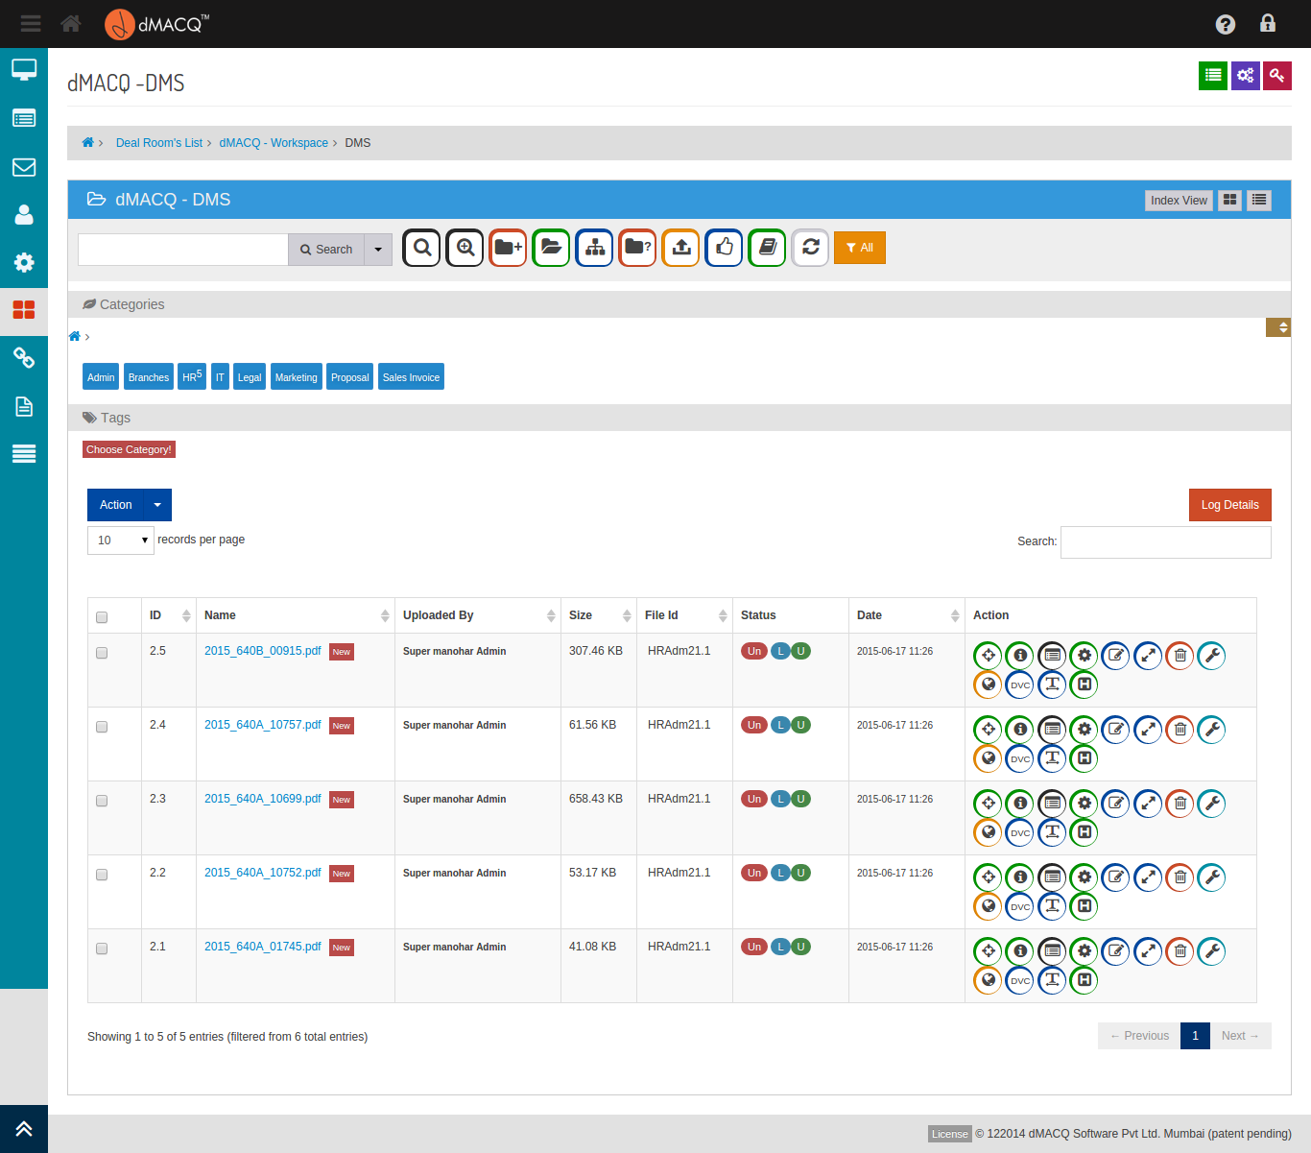

Screen . - The main DMS

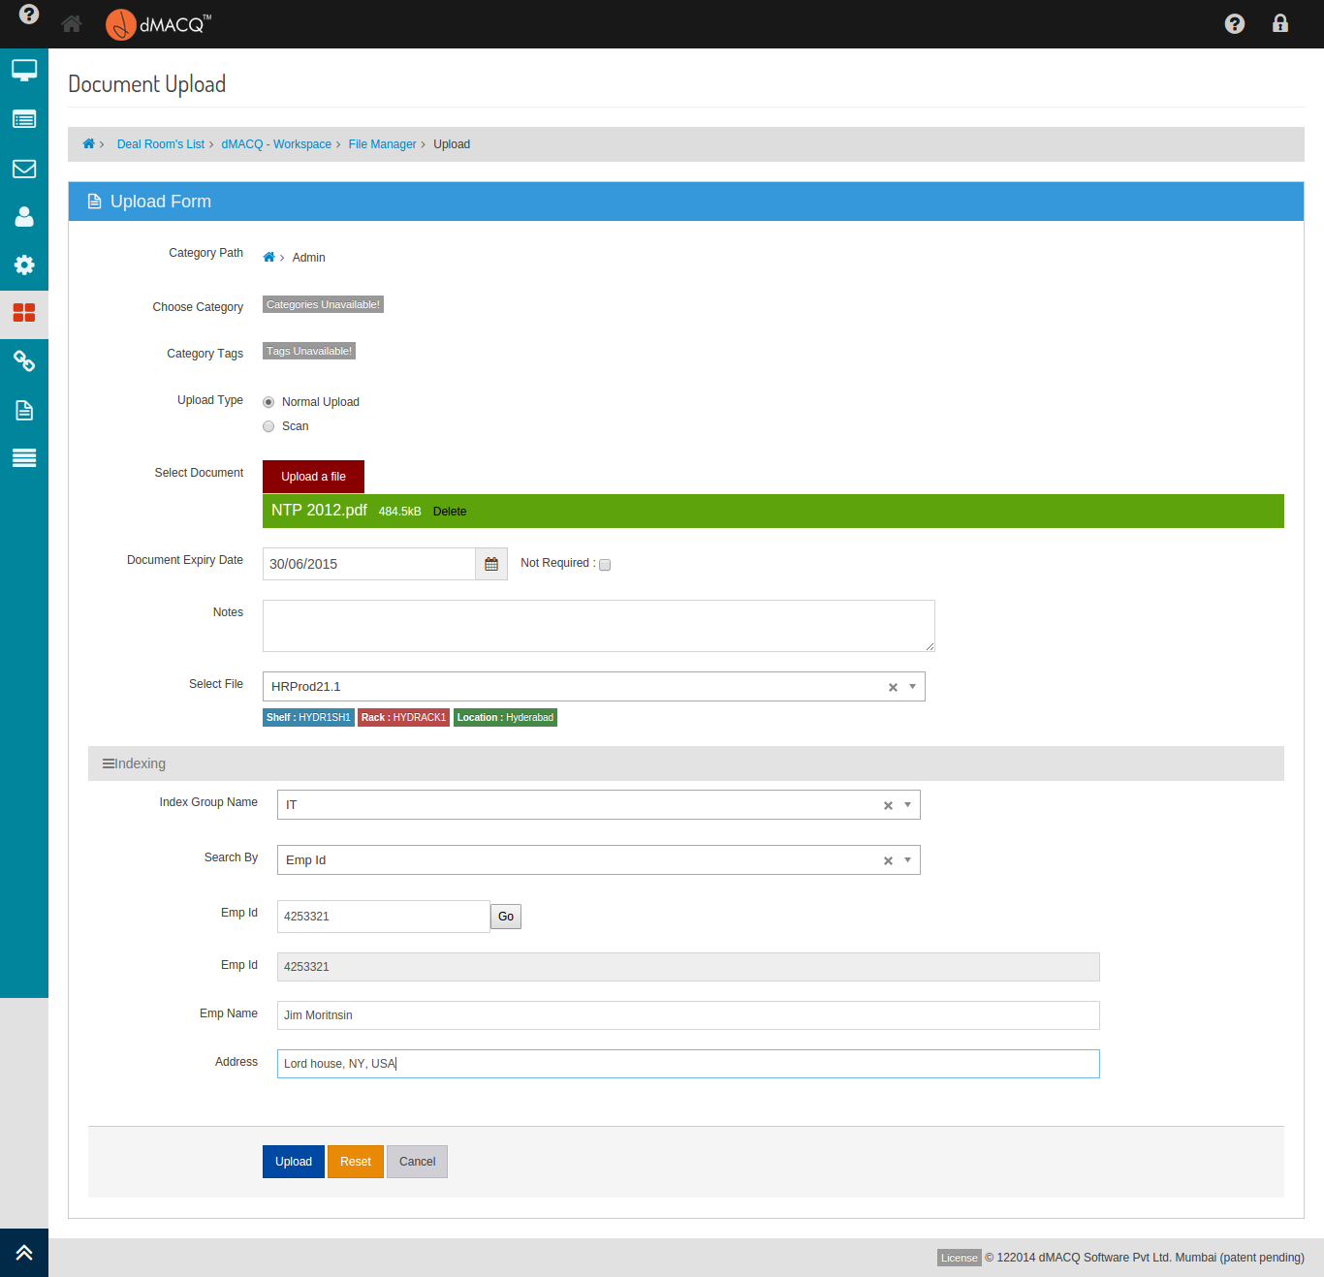

Screen . - DMS Upload

## The Bulk Mail System

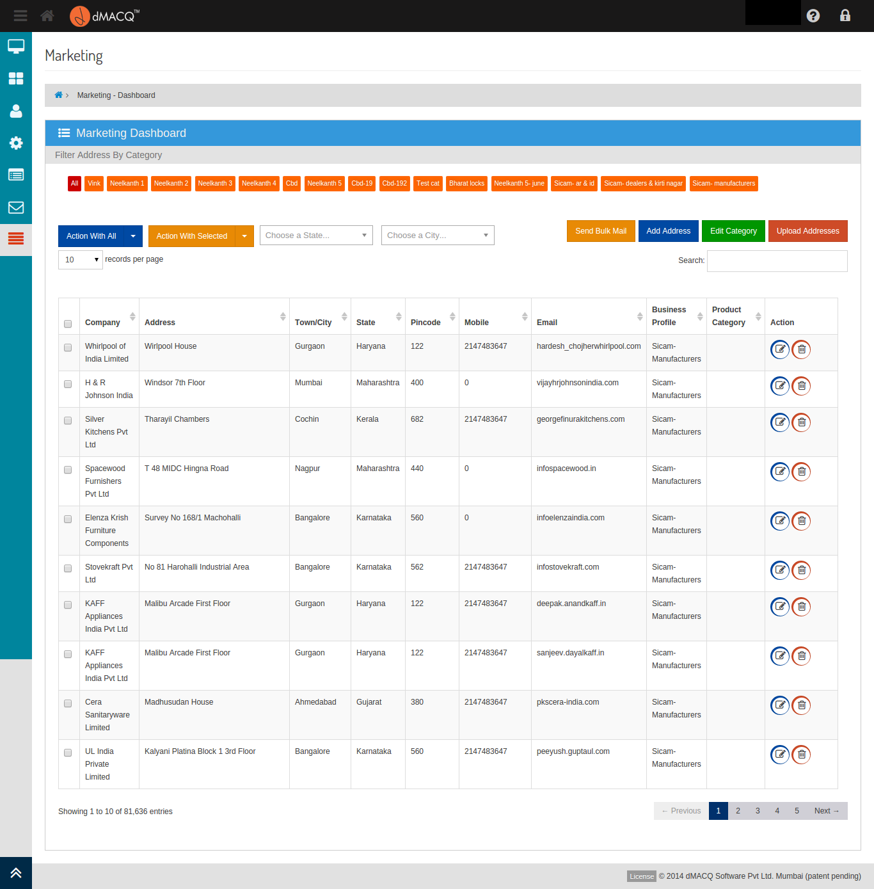

Screen . - Marketing Addresses

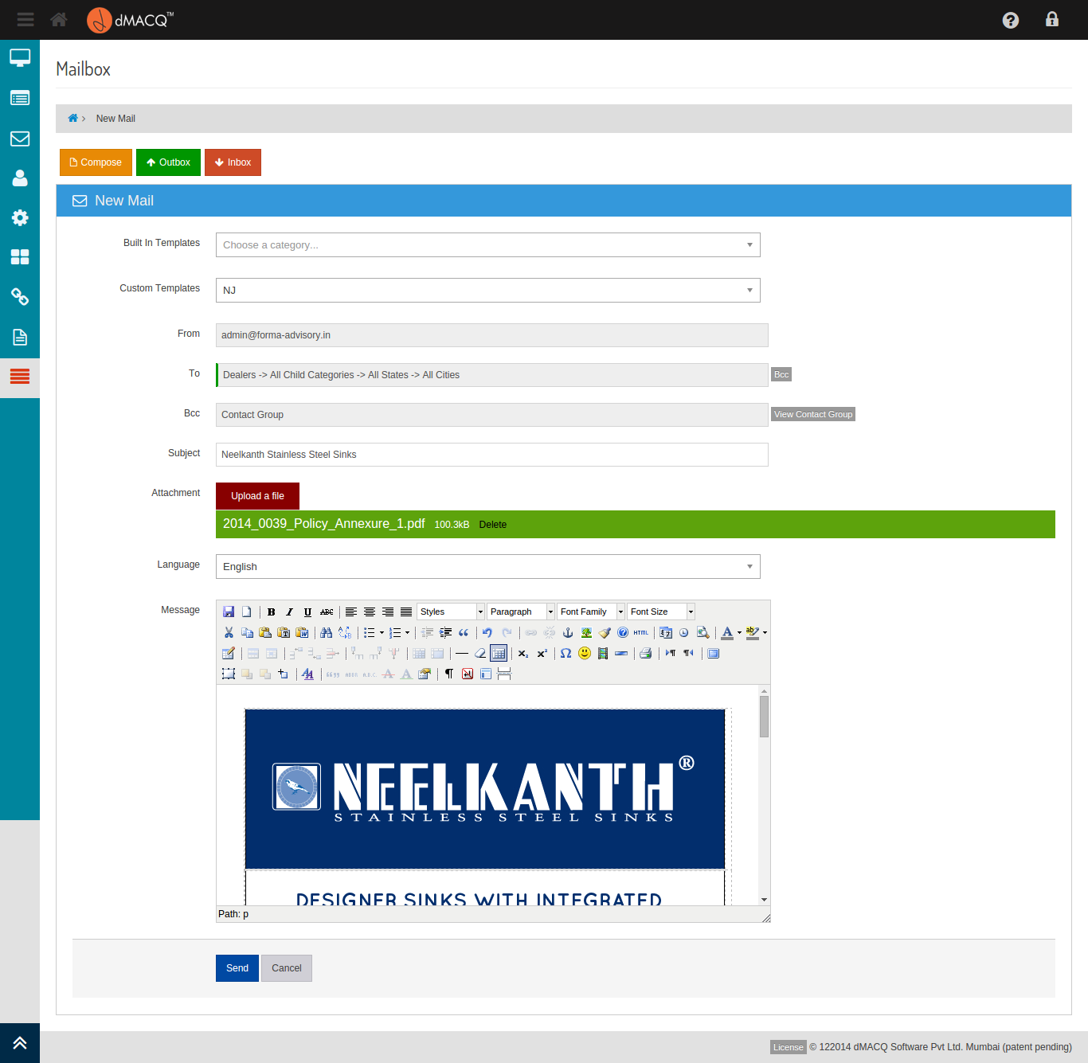

Screen . - Composing a bulk mail

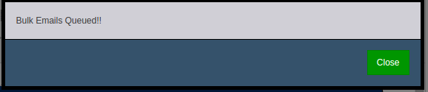

Screen . - Successfully entered into the bulk queue

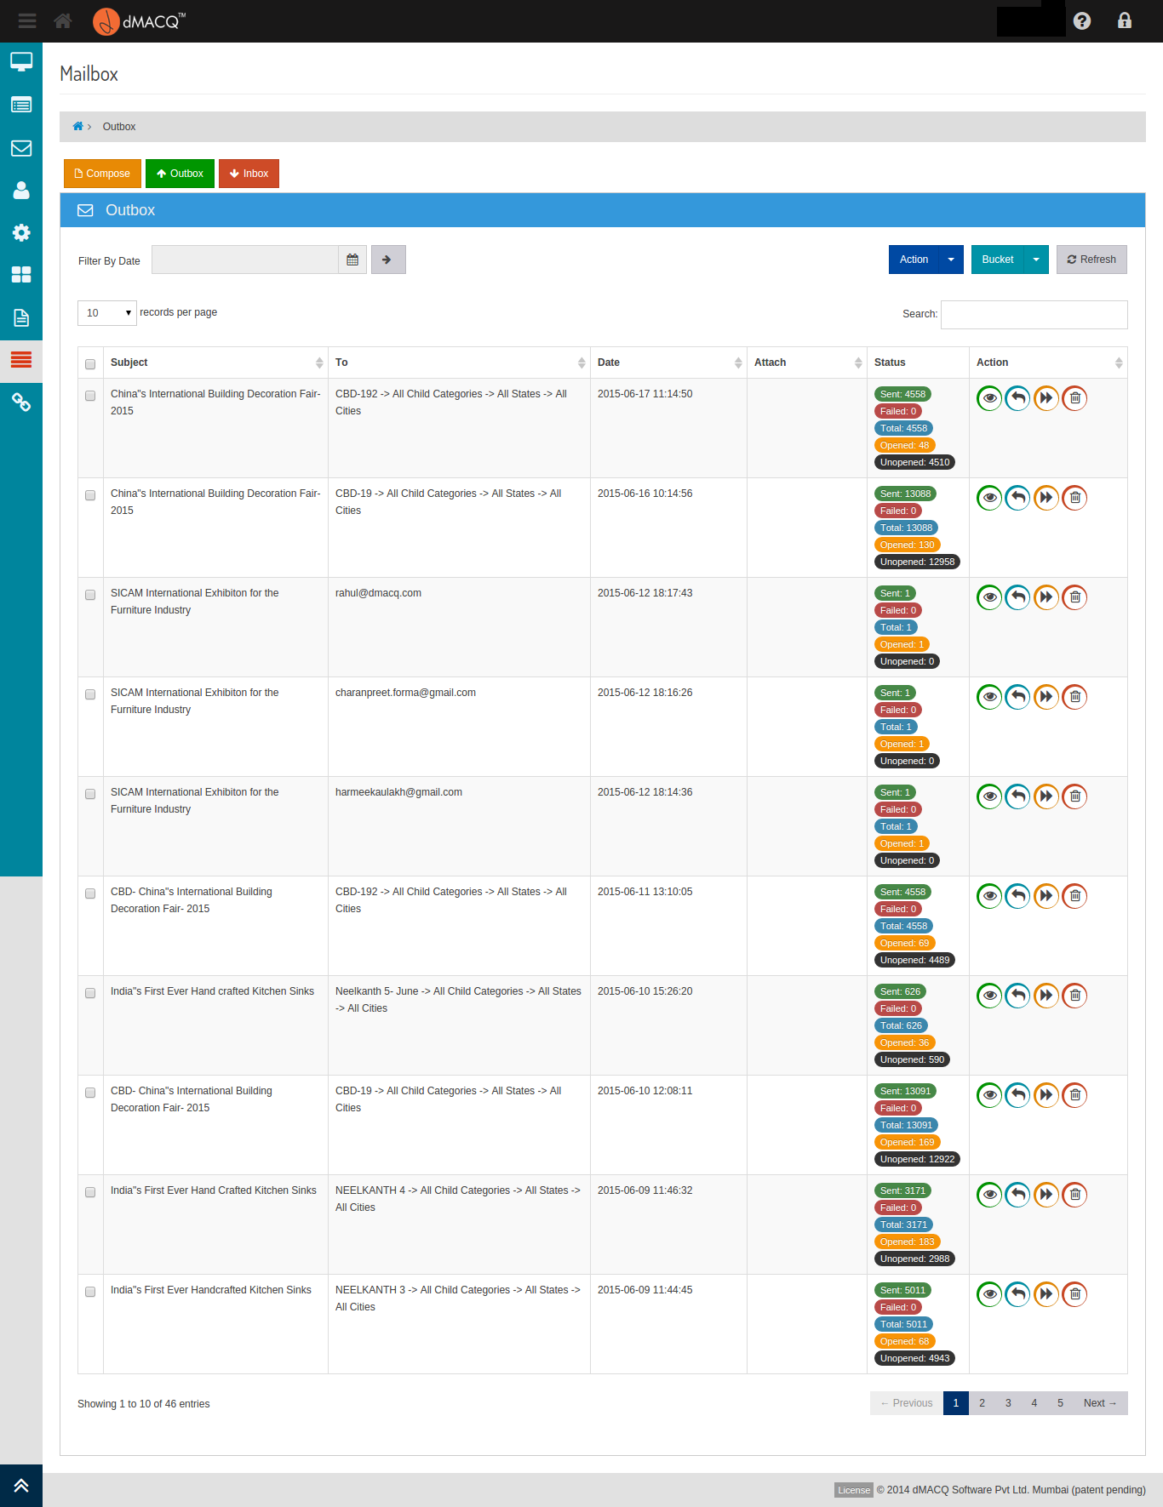

Screen . - Mail Outbox

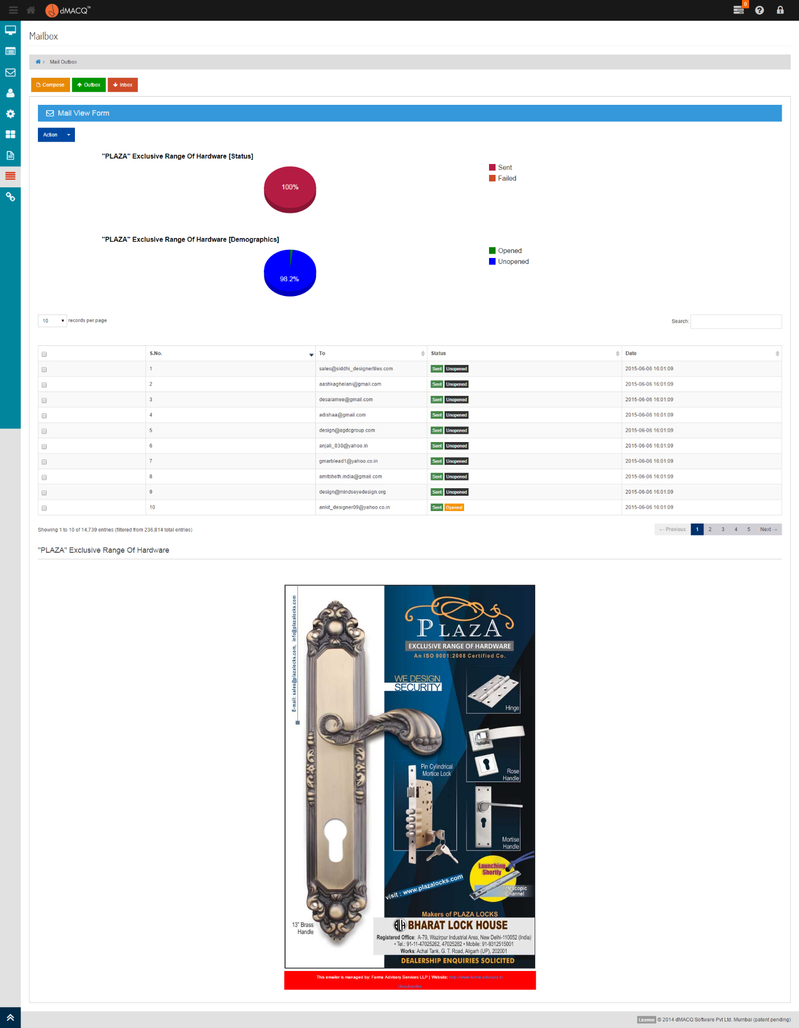

Screen . - Viewing A Mail

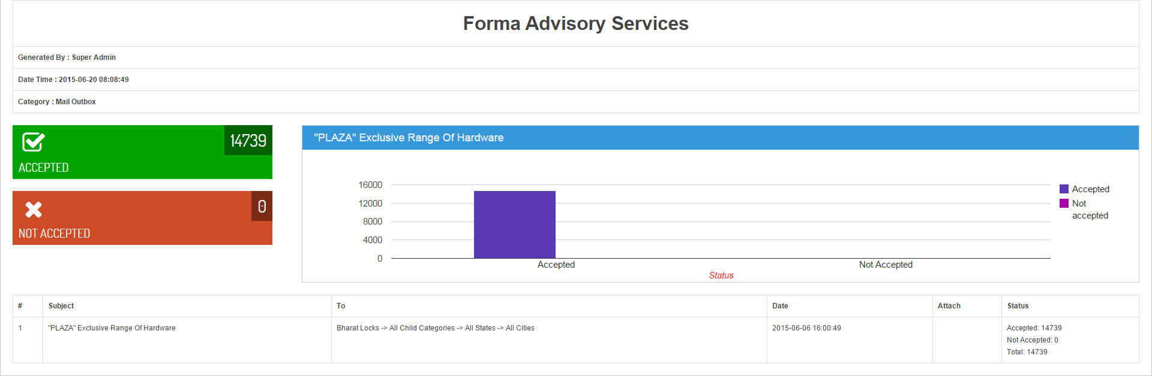

Screen . - Bulk Mail Report

## The Distributed File System

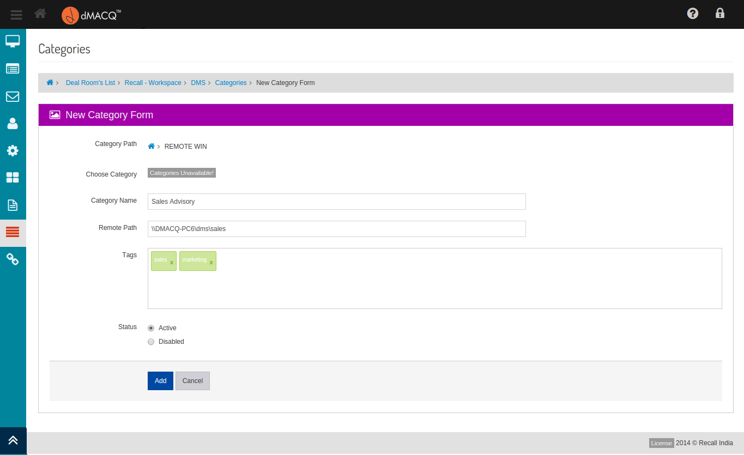

Screen . - Creating a new category with a remote path

## The OCR Queue



Screen . – Document OCR in progress

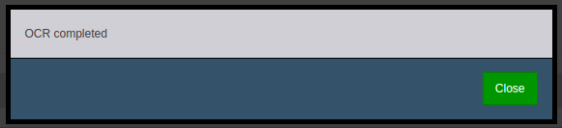

Screen . - Manually clicking on OCR to trigger the process



Screen . - OCR already done in the background

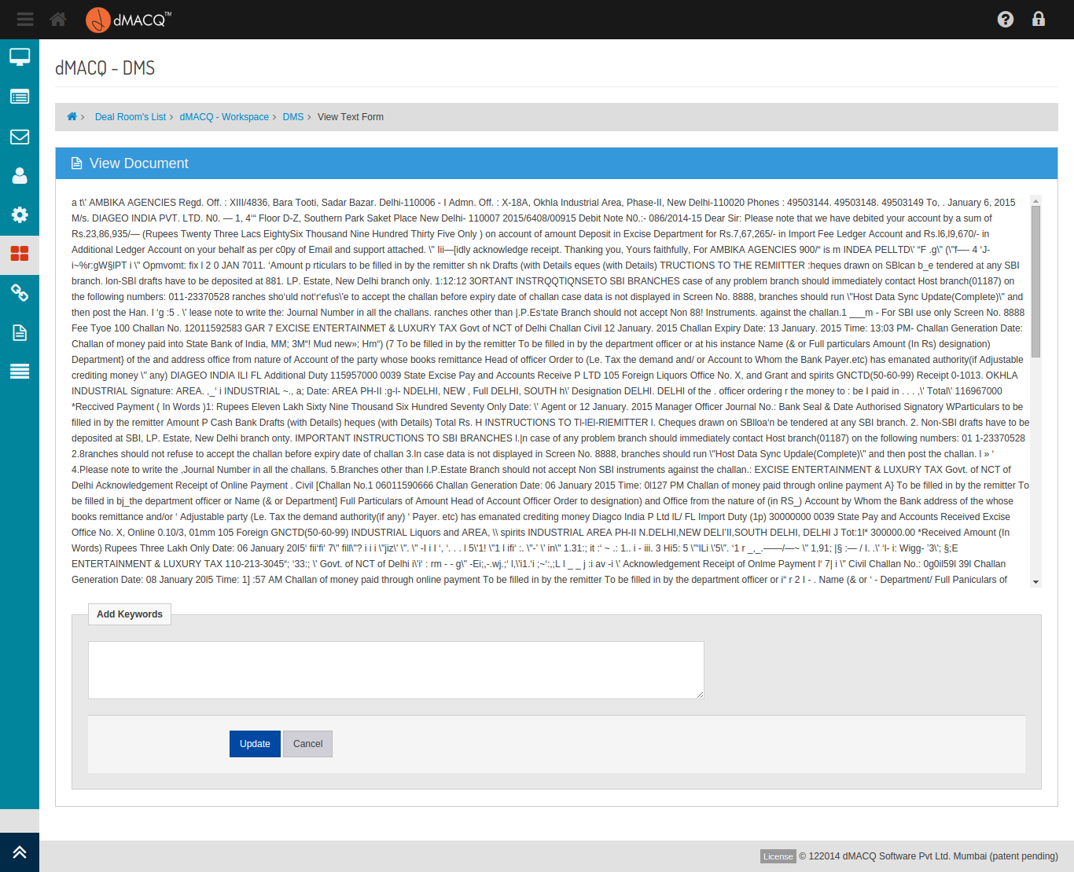

Screen . - The output of an OCR

## The interactive in-application help system

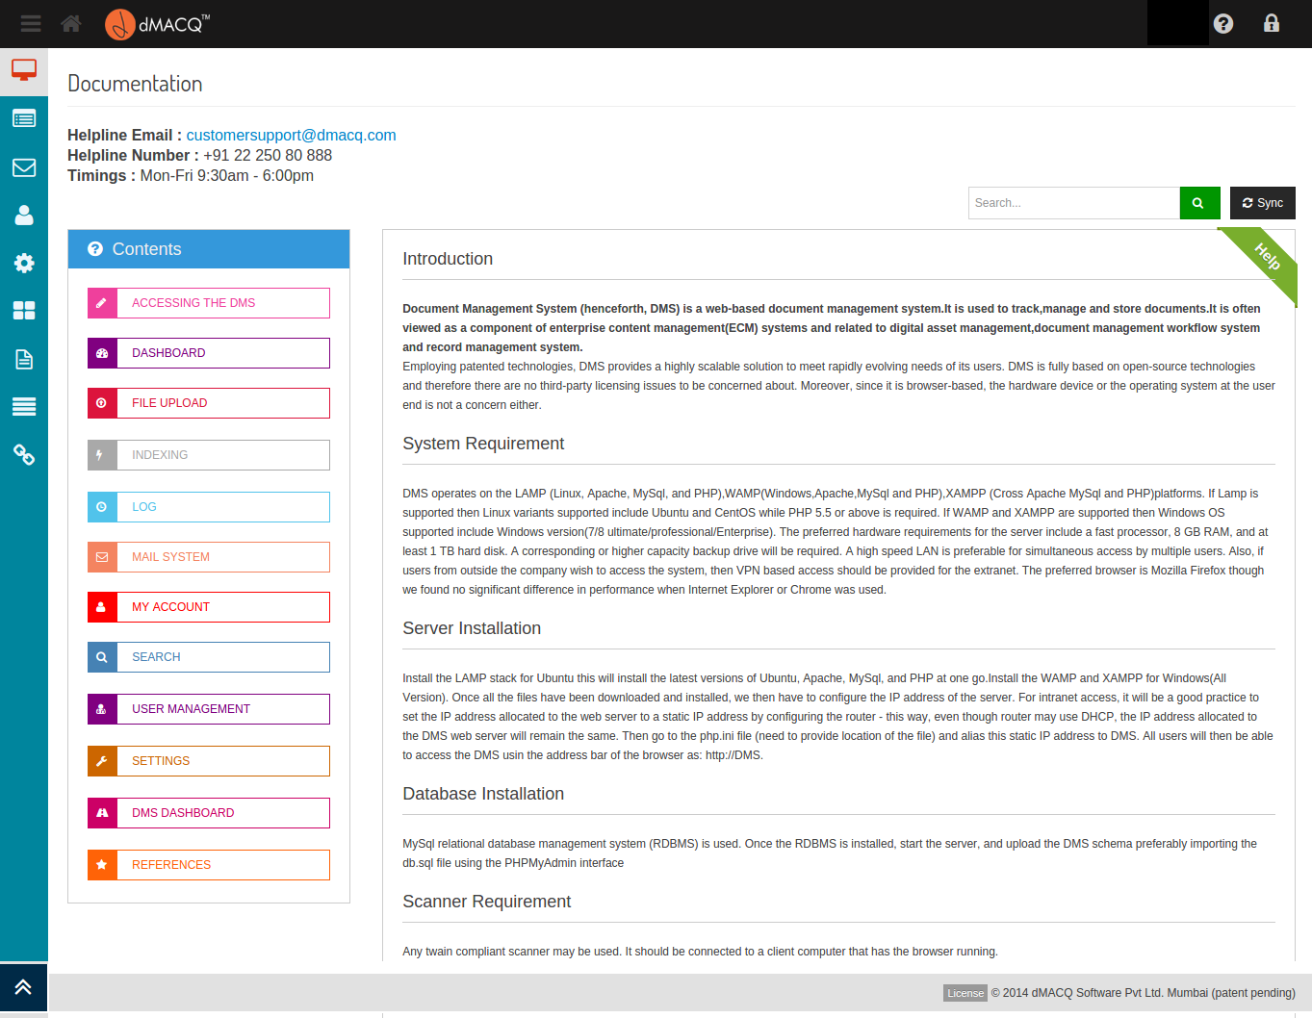

Screen . - The "Help" screen

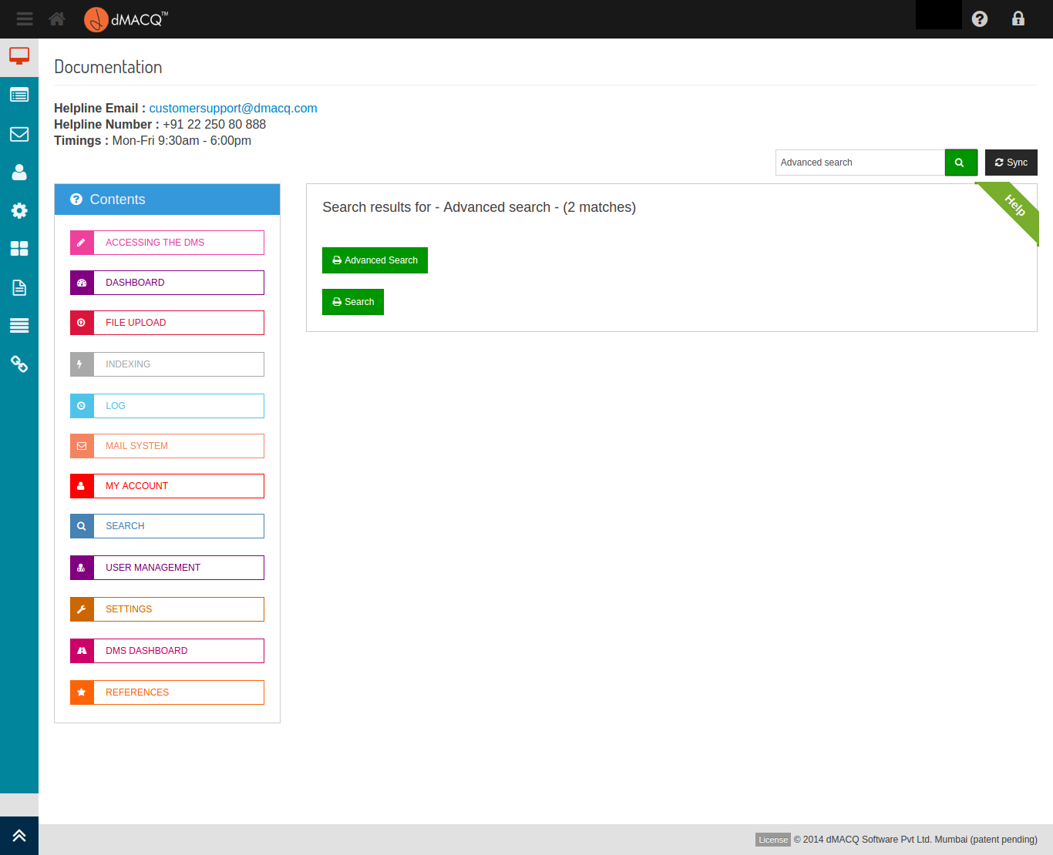

Screen . - Search results within the help display

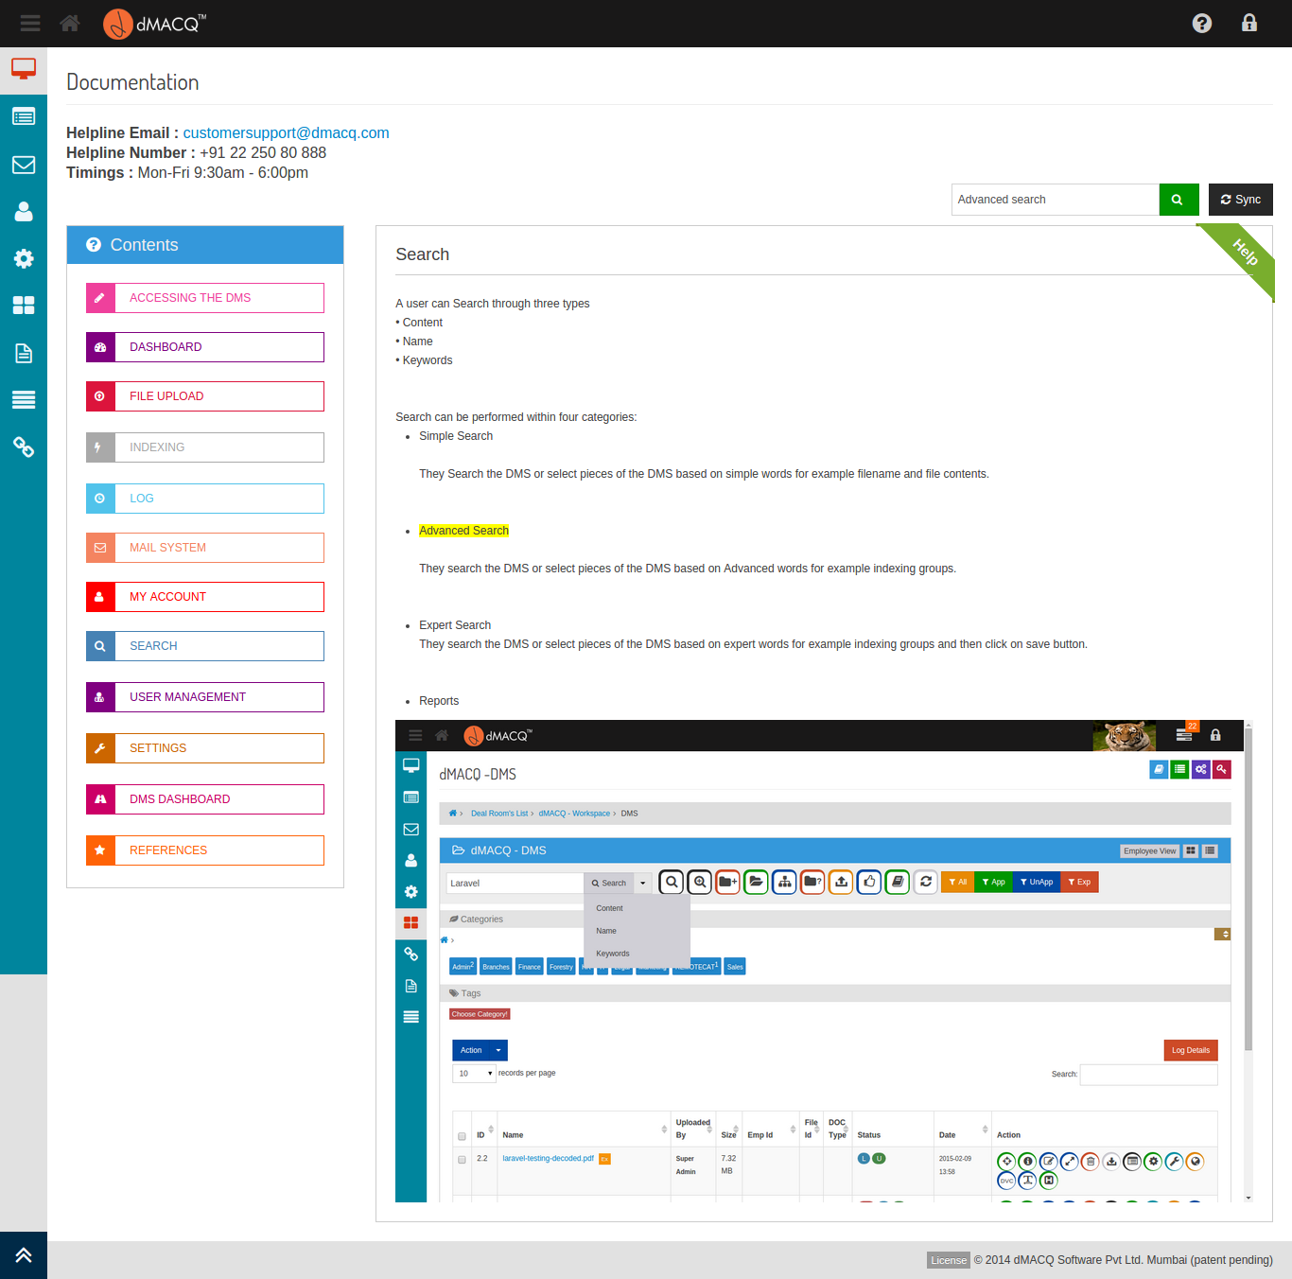

Screen . - Automatic highlighting of search text occurrences

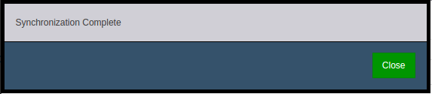

Screen . - Synchronizing an individual page

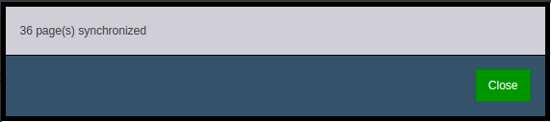

Screen . - Synchronizing all pages

## File Movement Tracker (FMT)

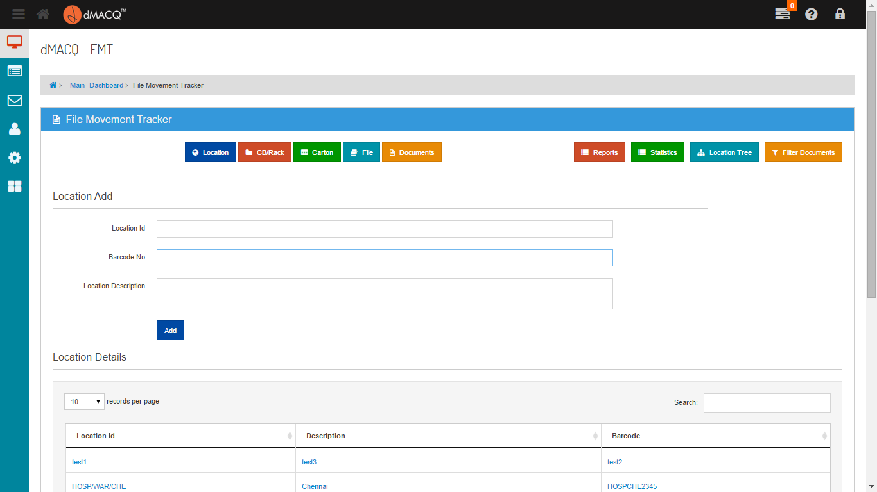

View the Location Details

Give the details of its location its id, Barcode and description

Click here to Add the location

Screen . - Add Location

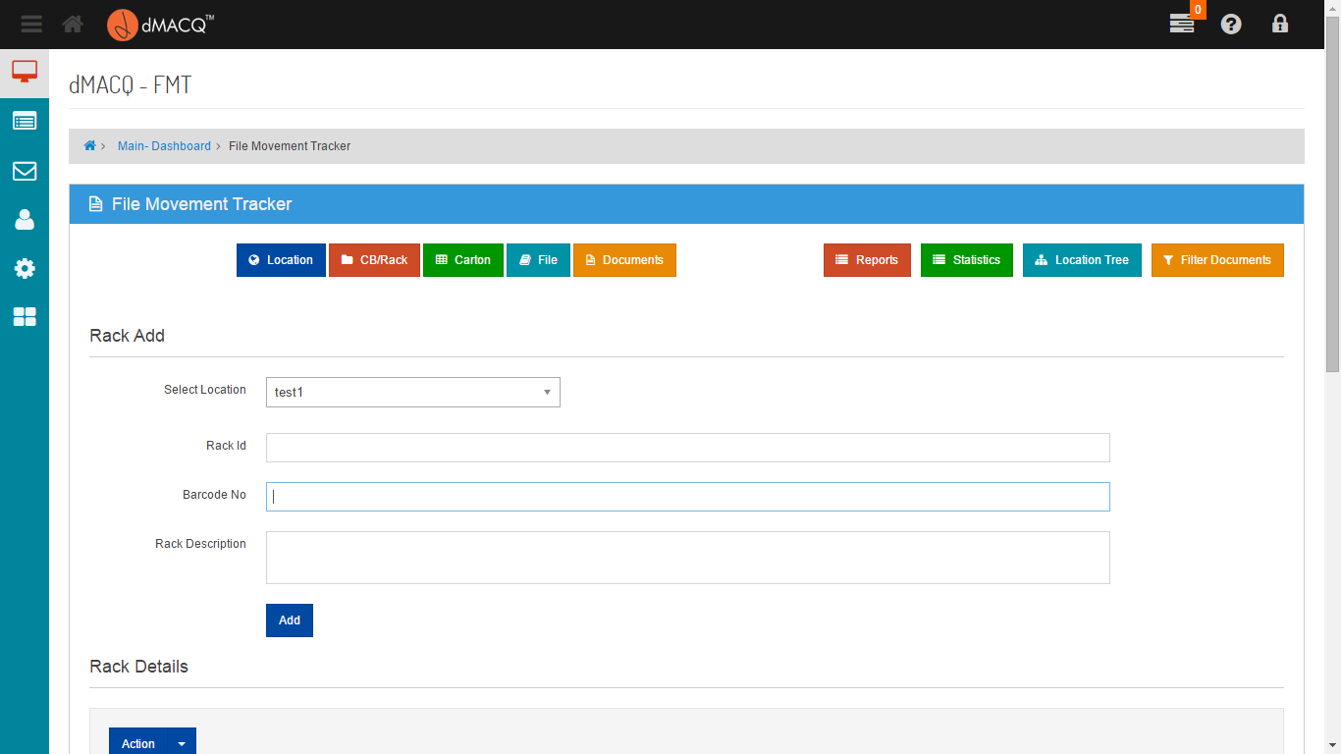

Give the details of the location and the rack id, its barcode and description

Click here to Add the Rack

Screen . - Add CB / Rack

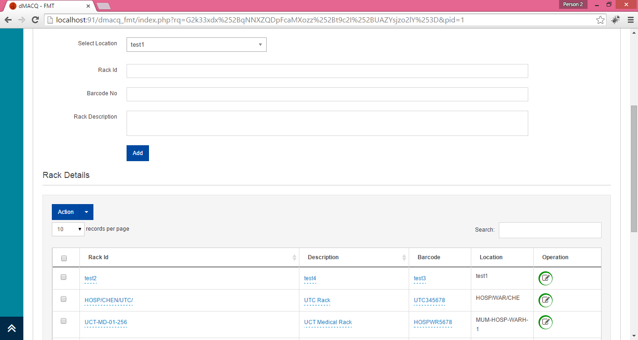

View the Rack Details

Screen . - Rack Details

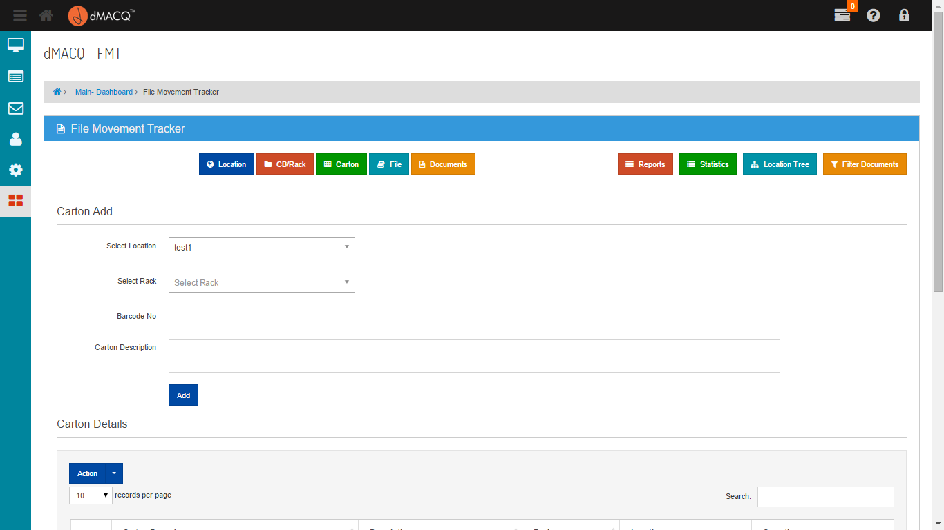

Click here to add Carton

Give the details of the location and the rack, Carton id its barcode and description

Screen . - Add Carton

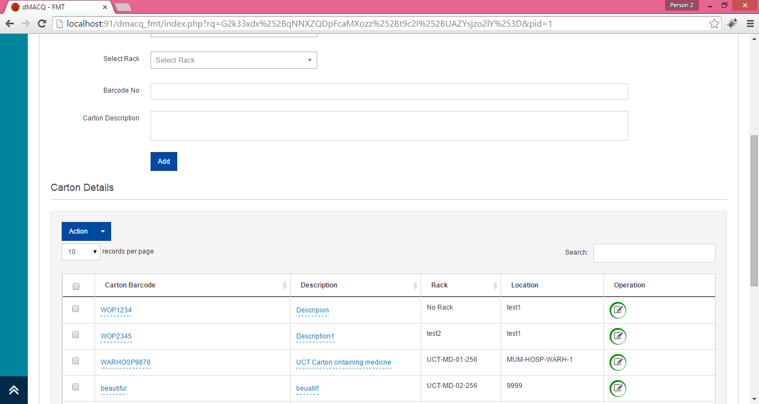

View Details of the Carton

Screen . - Carton Details

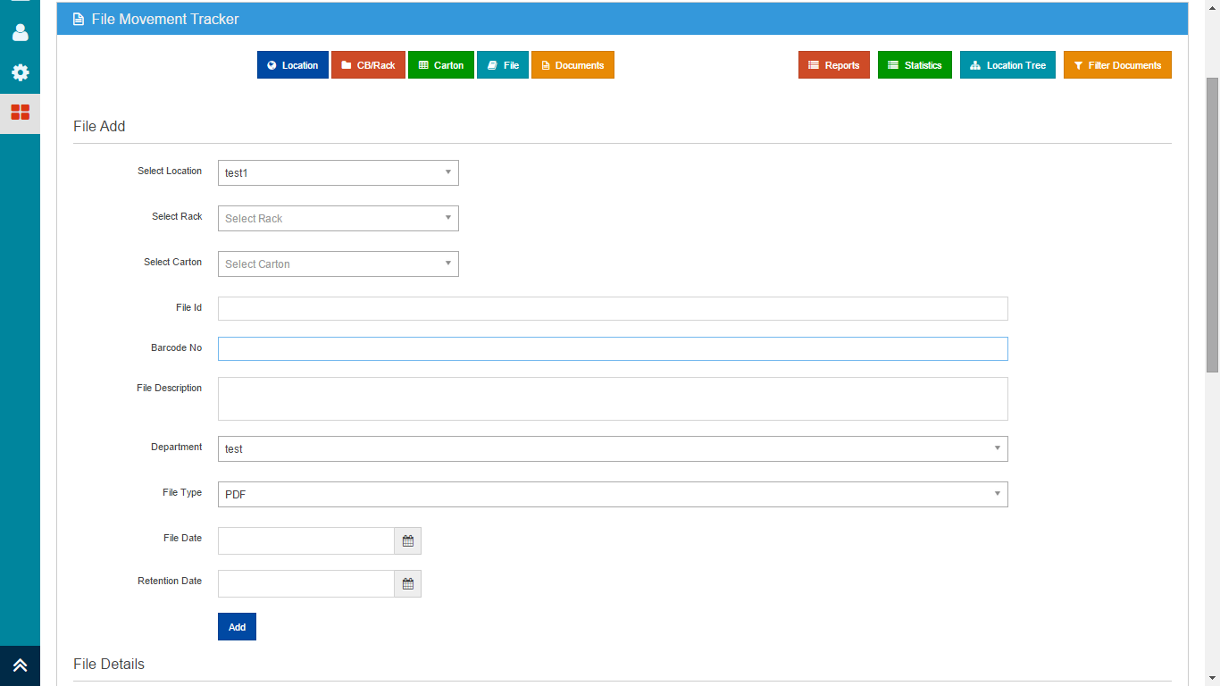

Give the details of the location, rack, carton and add file id its barcode, description its department, file type ,file date and retention date

Click here to add File

Screen . - Add File

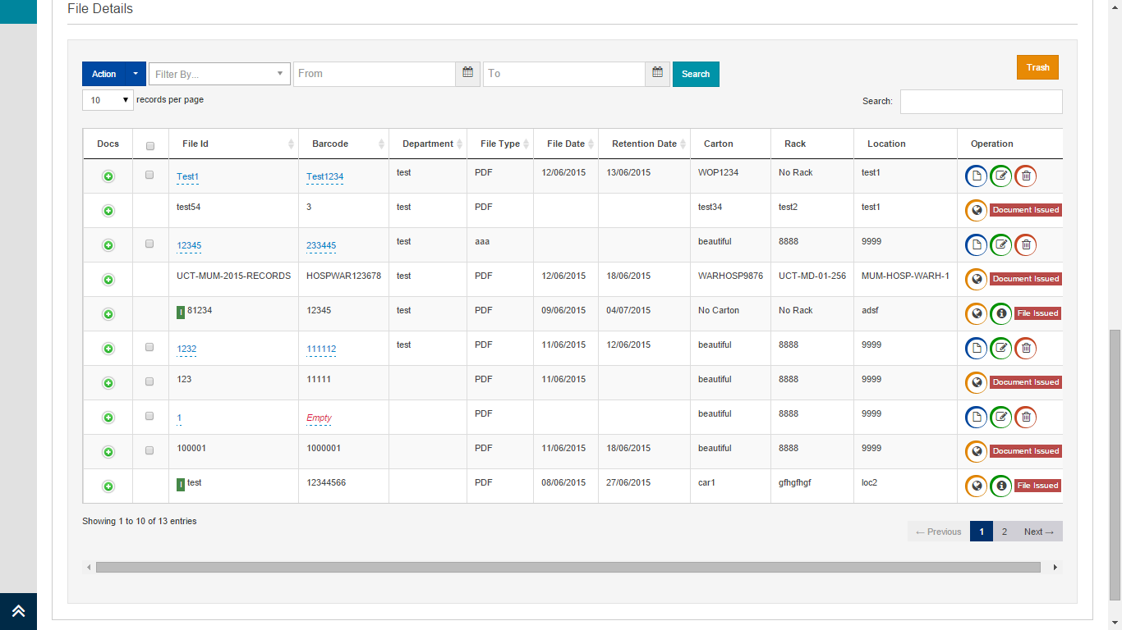

Click for Trash

Search by Retention Date and File date

Enter the Documents

Screen . - File Details

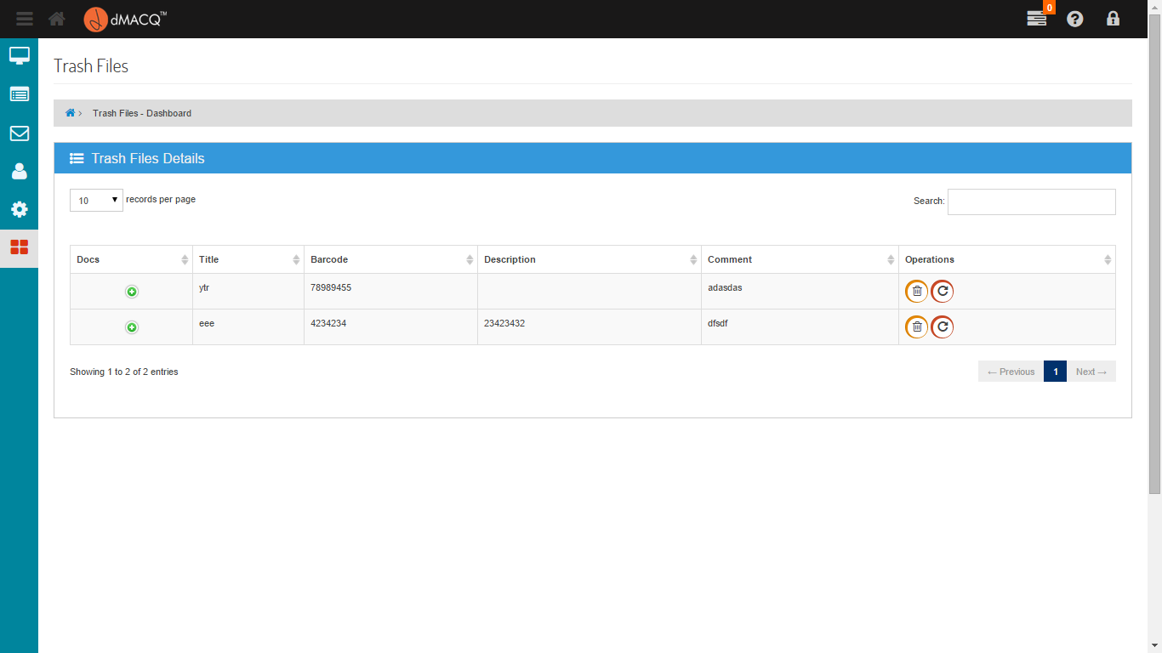

Click here to delete the file

Click here to restore the file

Screen . - Trash Dashboard

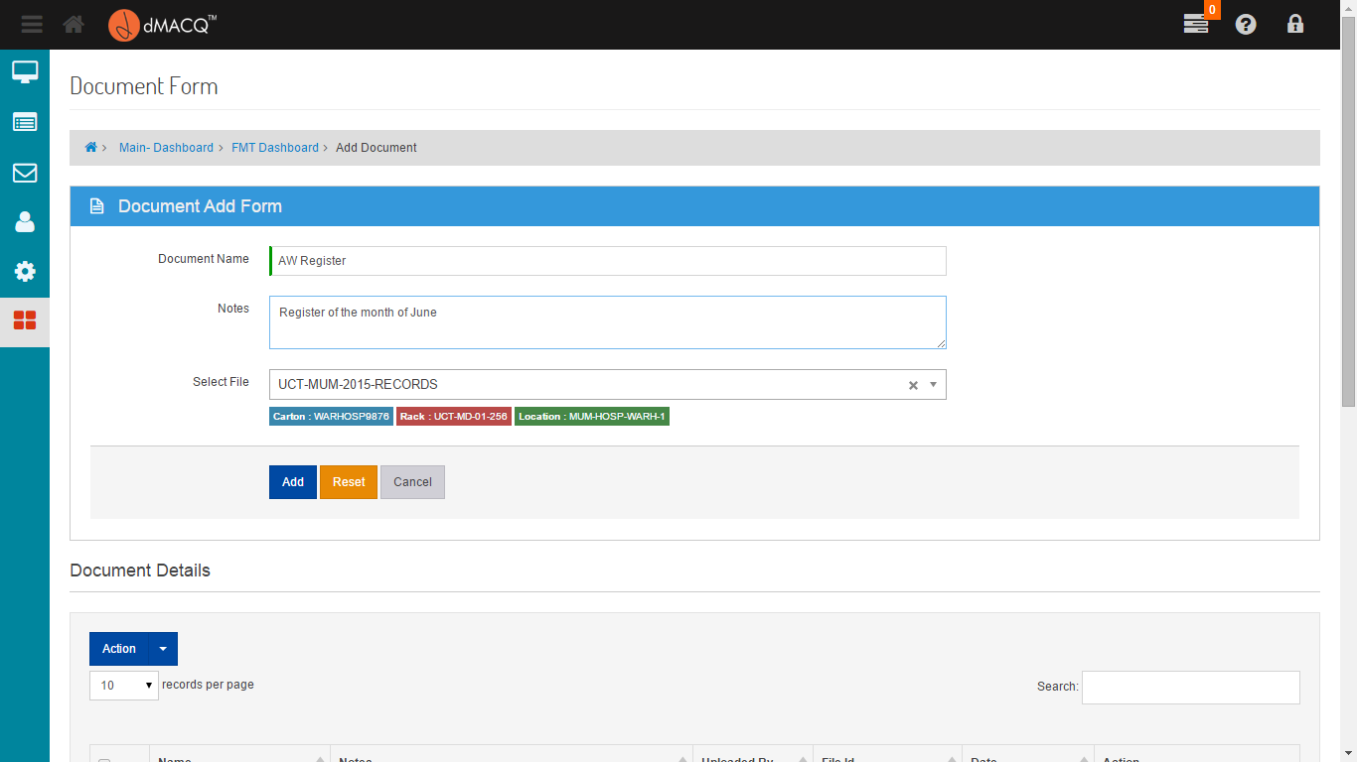

Select the File from the Dropdown

Add the Document Name

Screen . - Add Document

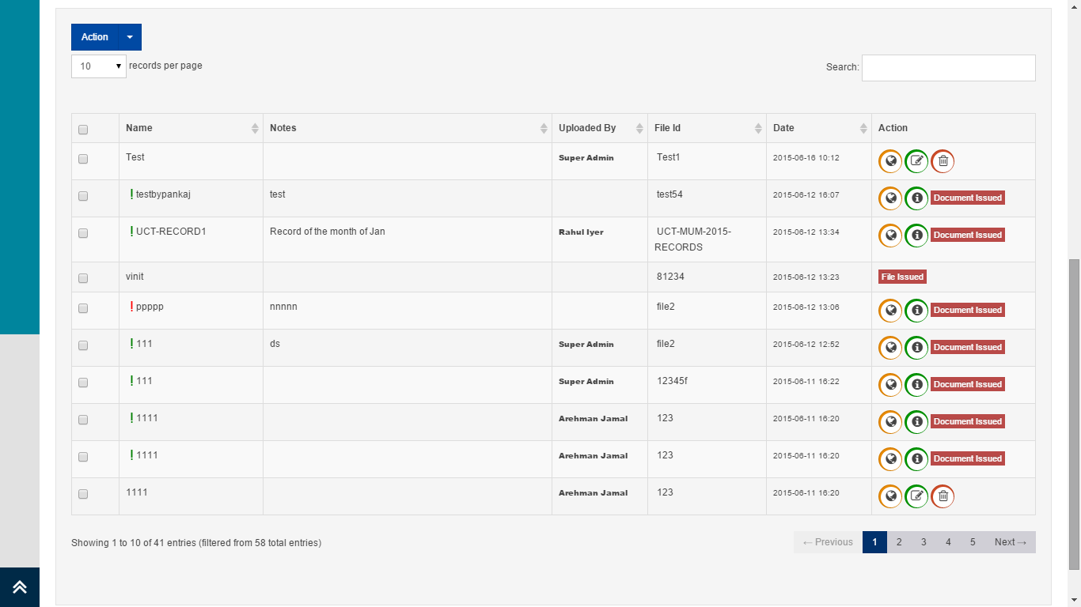

Click here to issue the document

Screen . - Document Details

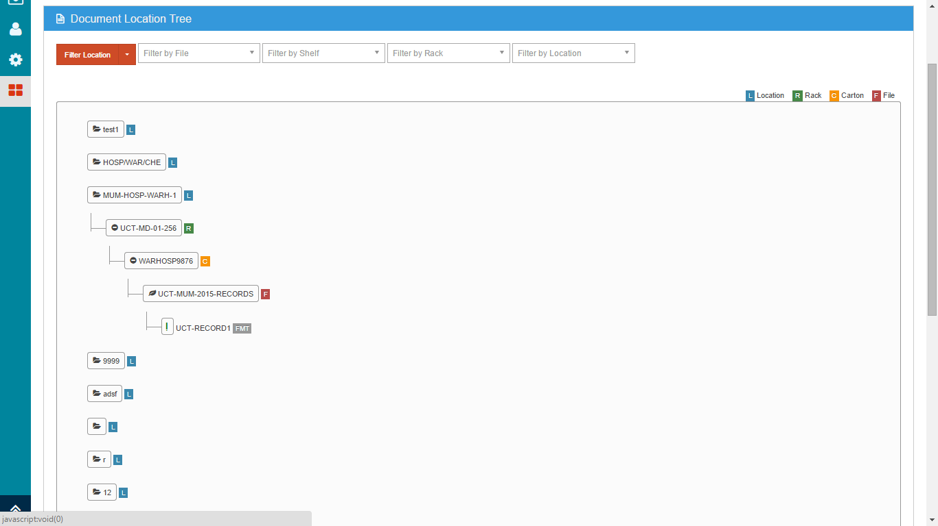

Filter the record by File,Shelf,Rack and Location

Screen . - Location Tree

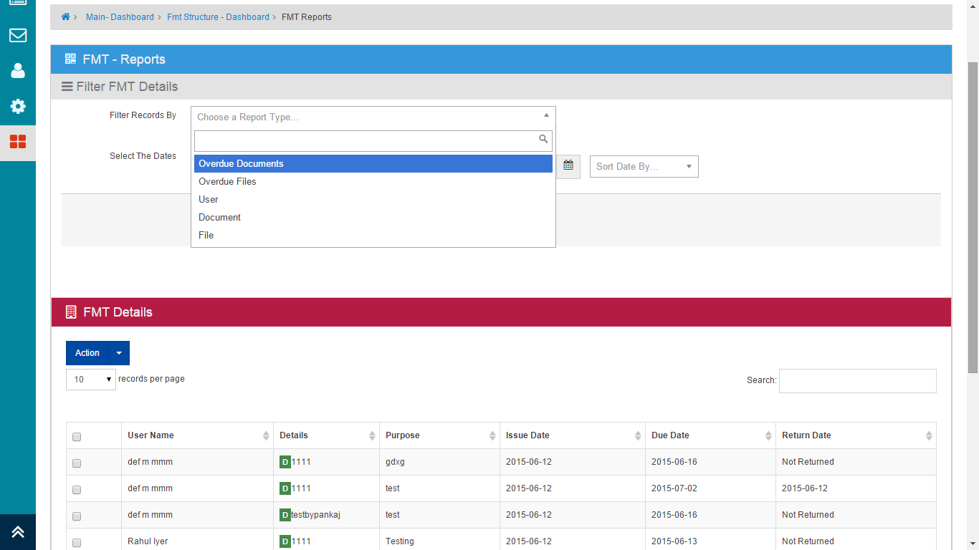

Screen . - FMT Reports

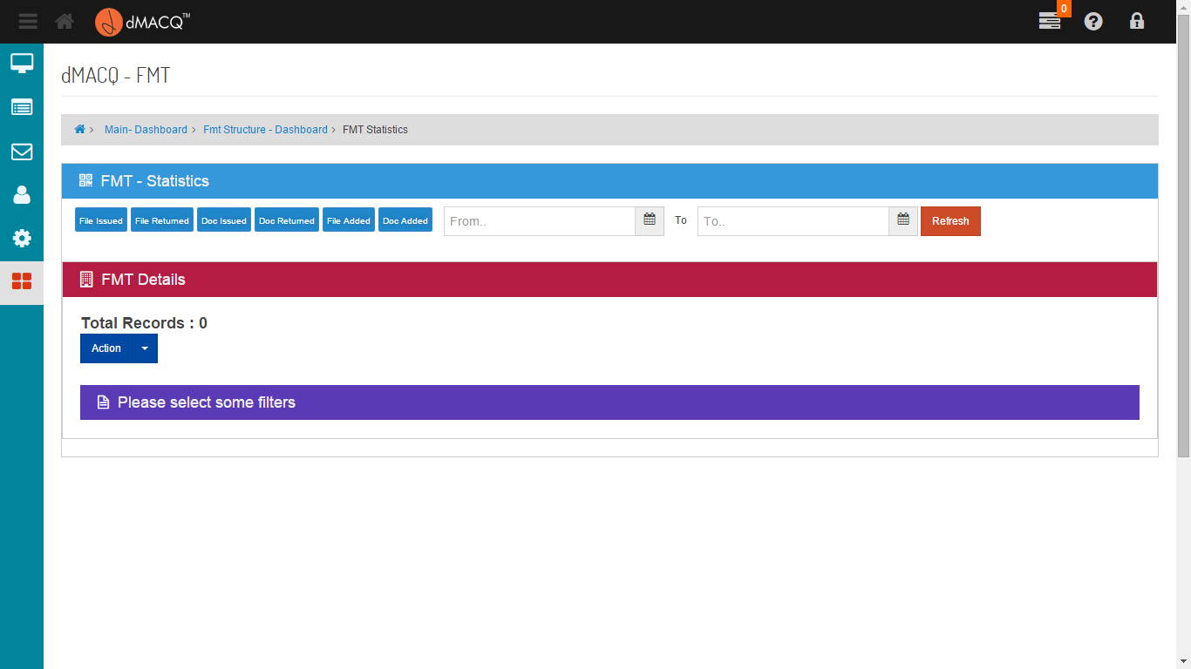

Filter the record by Files Issued, Files Returned, Doc Issued, Doc Returned, Files Added and Documents Added

Screen . - FMT Statistics

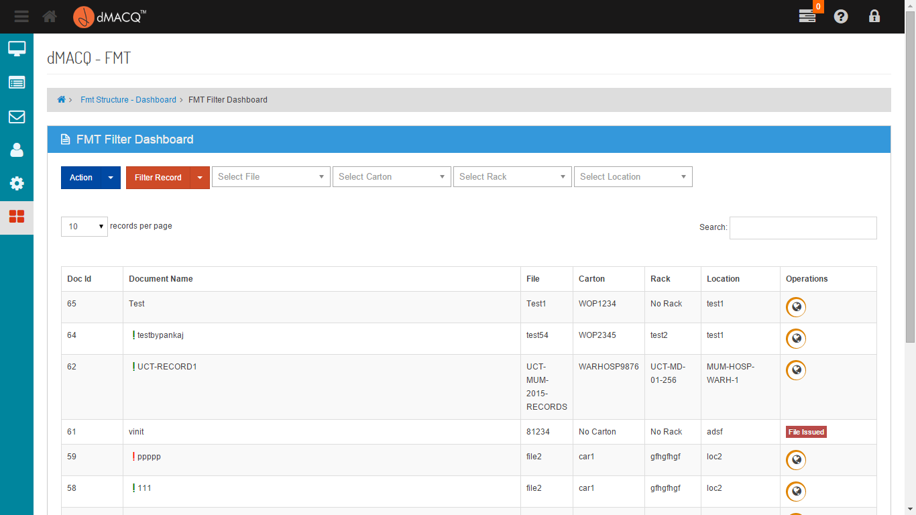

Click here to issue the Document

Filter the record by File,Shelf,Rack and Location

Screen . - Filter Documents

## Advanced Search

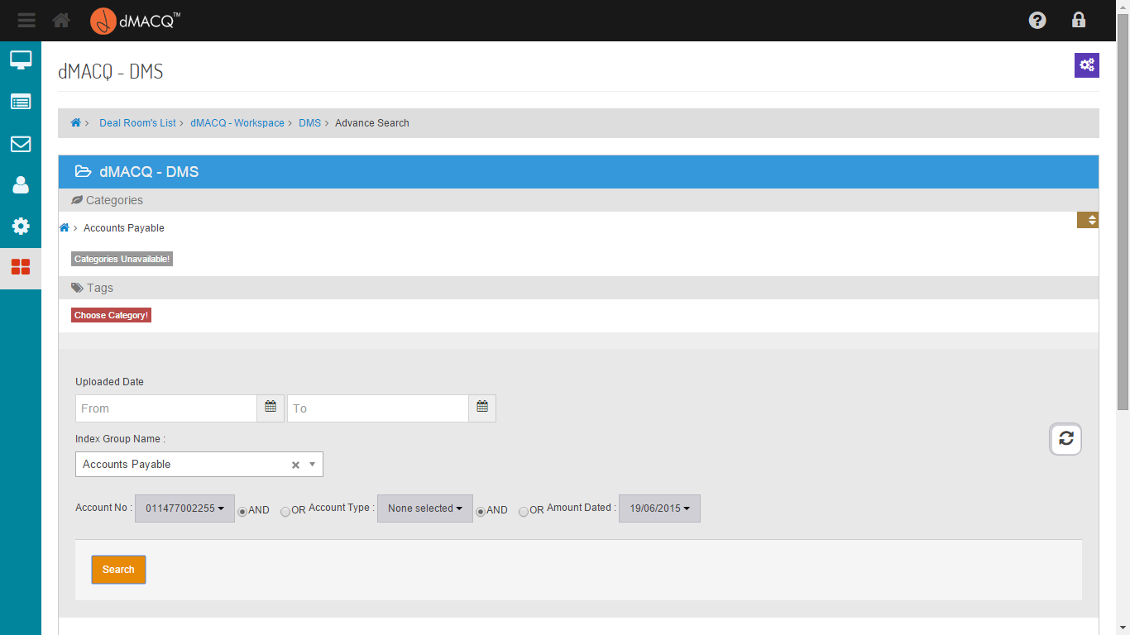

Choose the Category

Select the Index Group Name and filter by Index Fields

Search the Document From Uploaded Date

Screen . - Main Search Menu

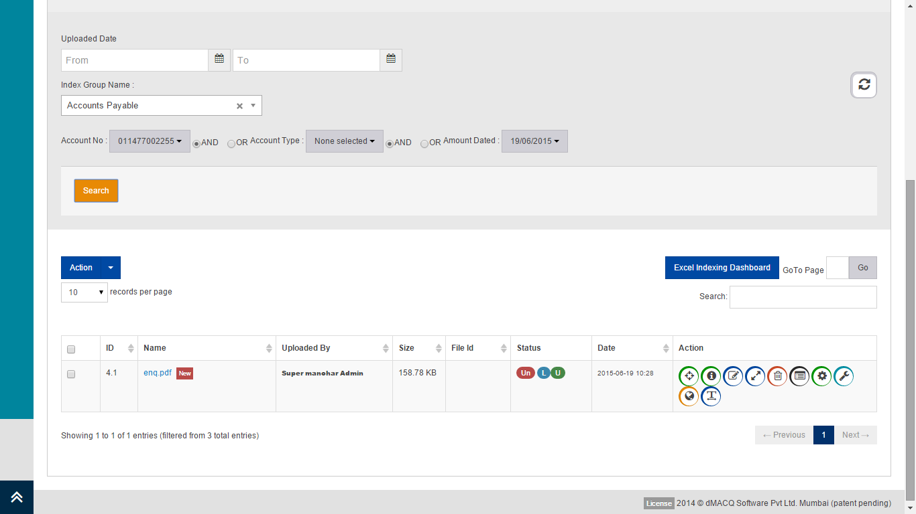

Document Searched By the Index Group

Screen . - Search Results

## Expert Search

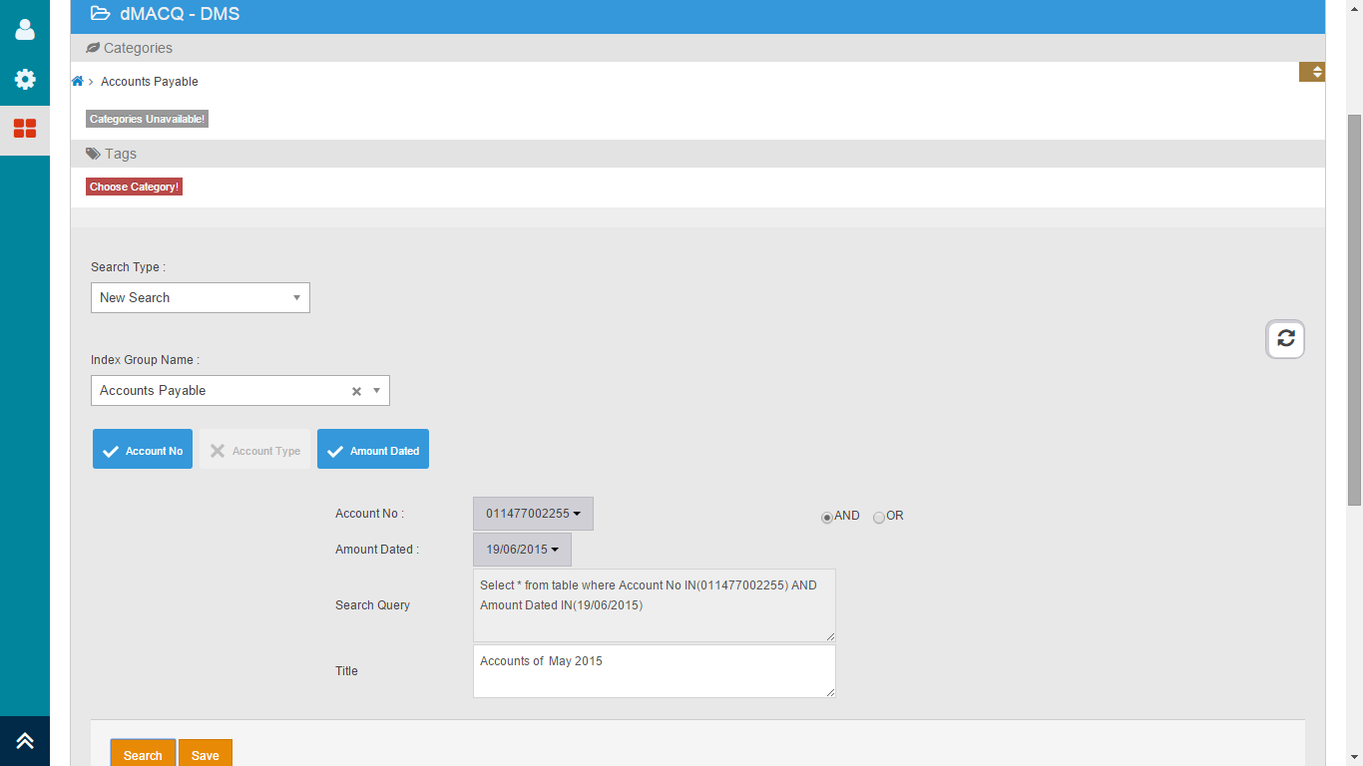

Click here to save the search

Choose the Category

Select the Index Group Name and filter by Index Fields

Select the Search Type

Screen . - Main Search Menu

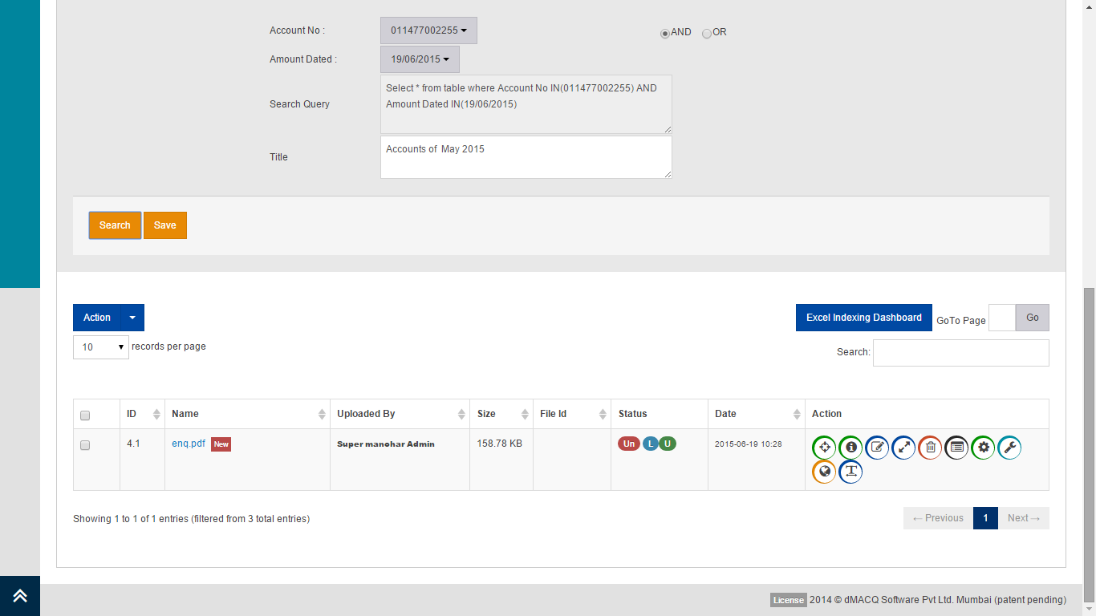

Document Searched By the Index Group

Screen . - Search Results

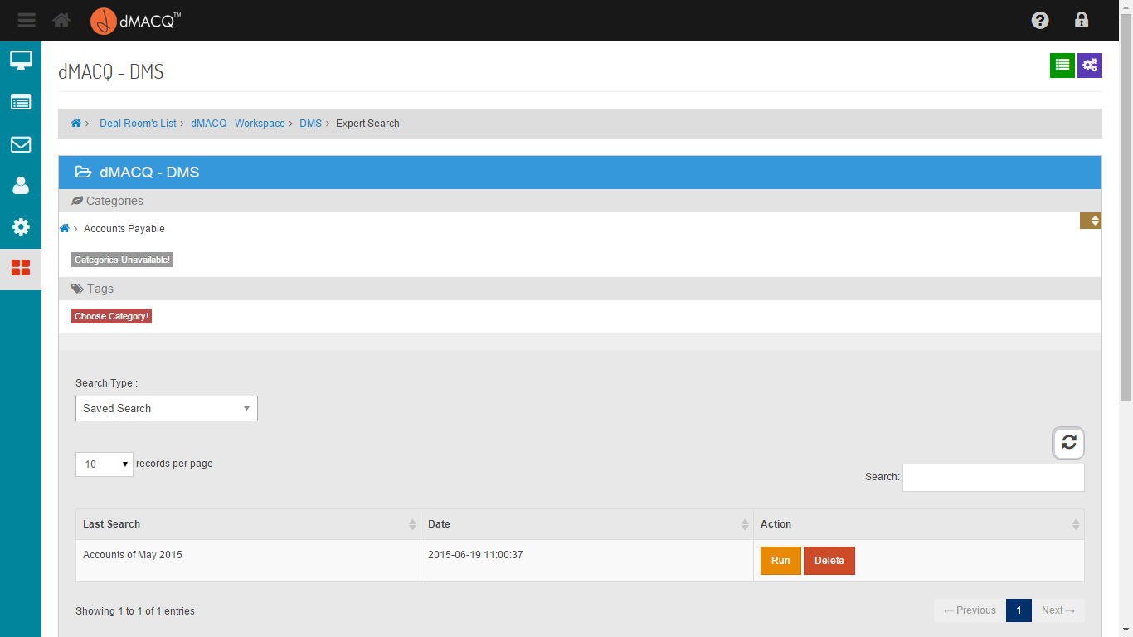

Delete the Saved Query

Run the Saved Query

Select the Category

Select the type of Search

Screen . - Running a Saved Search

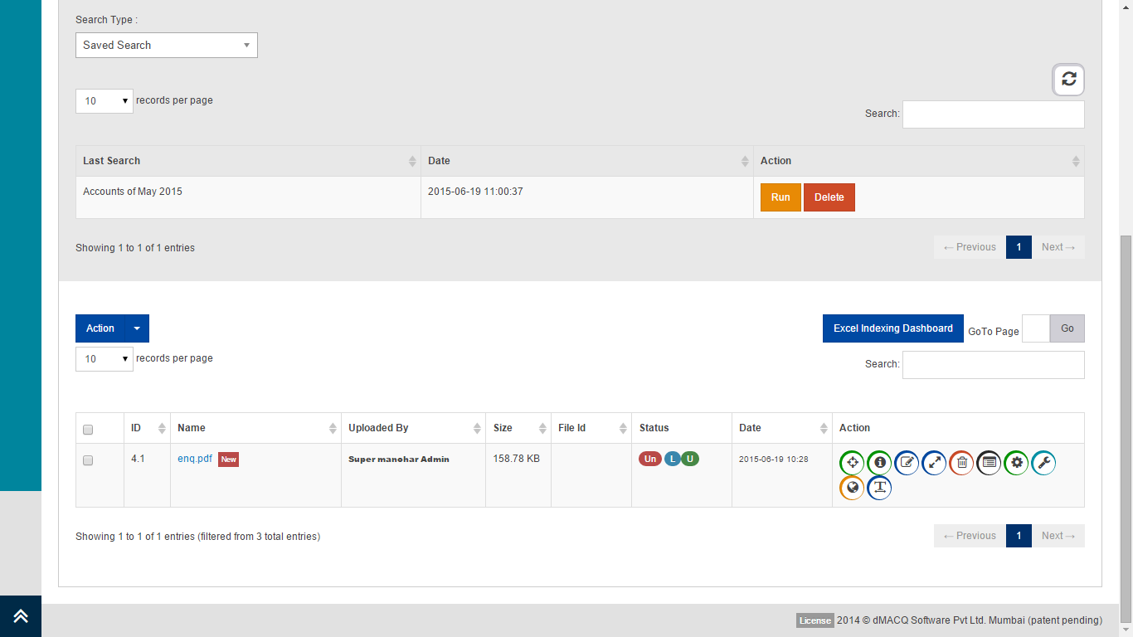

Document Searched By the Index Group

Screen . - Search Results

## Proposals

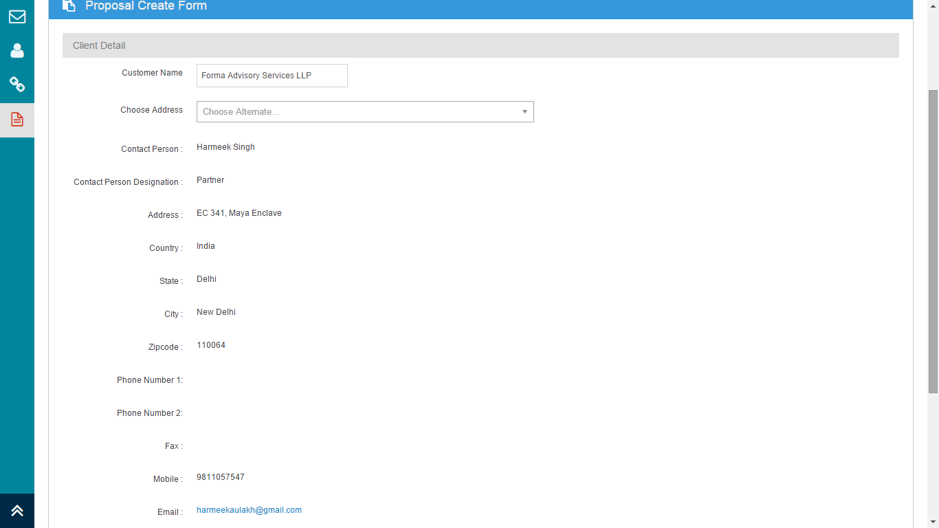

Screen . - Create Proposal (Client)

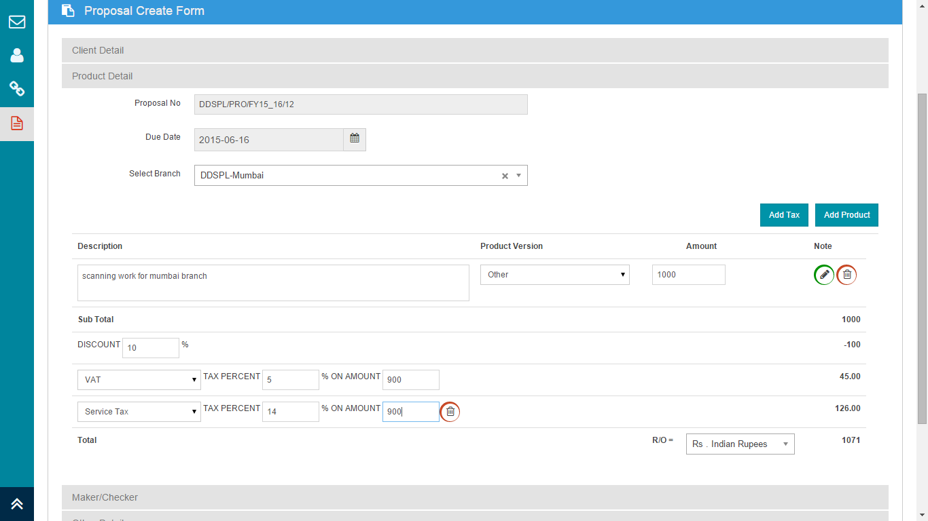

Screen . – Create Proposal (Product Details)

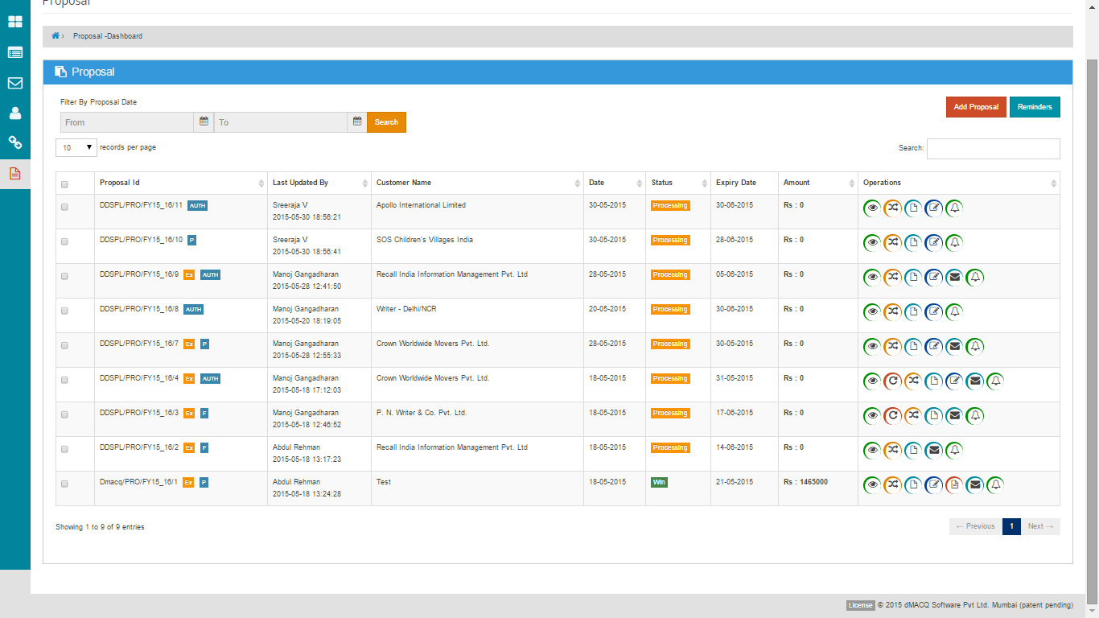

Screen . - Proposal Dashboard

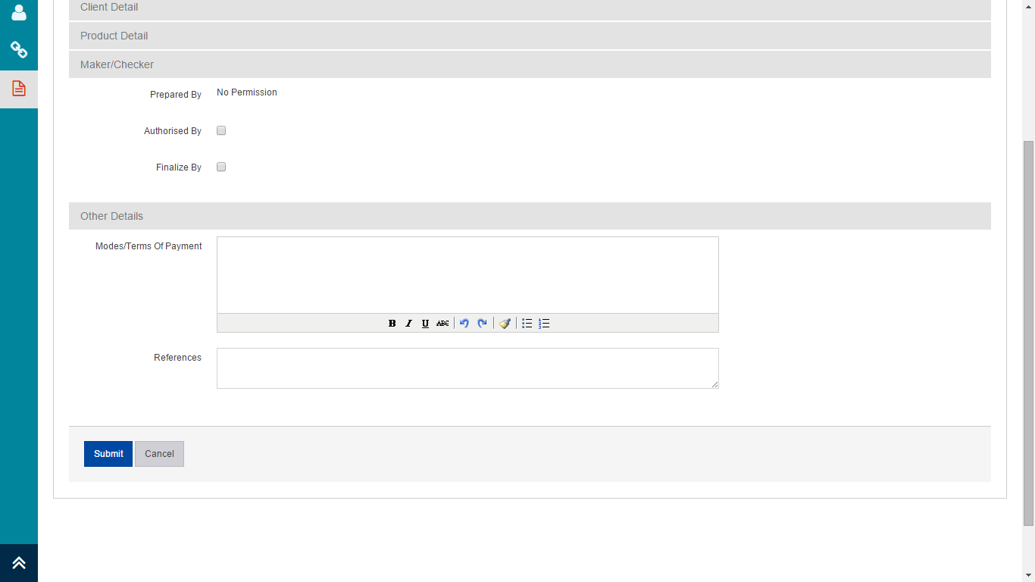

Screen . - Maker / Checker Details

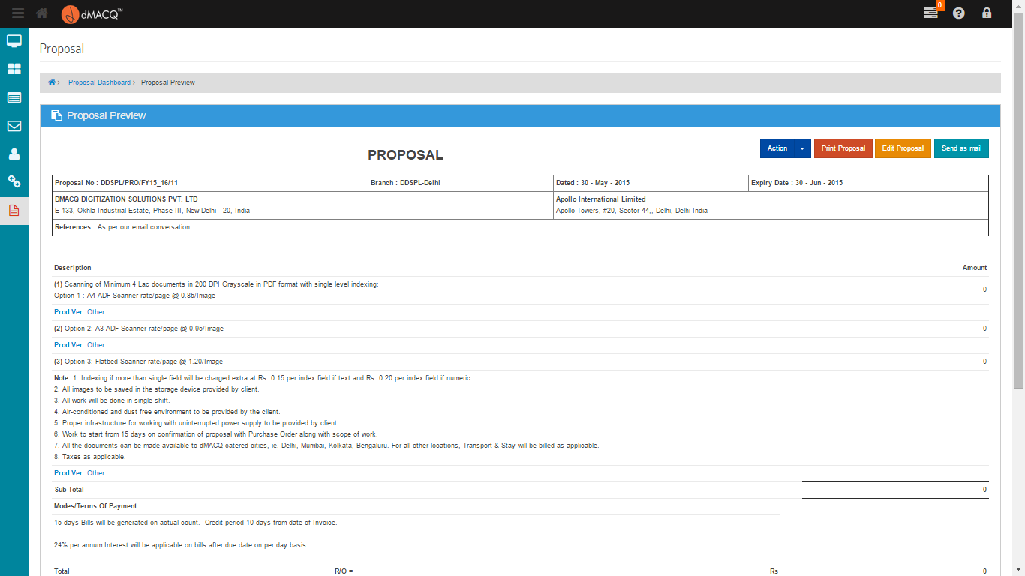

Screen . - View Proposal

## Sales Invoice

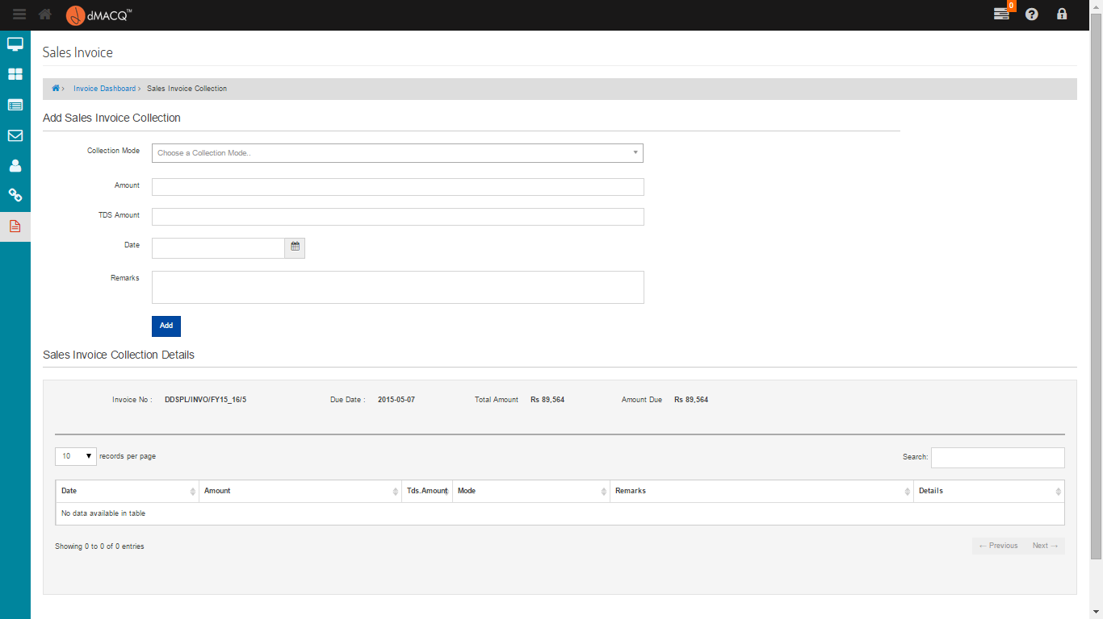

Screen . - Collection Details

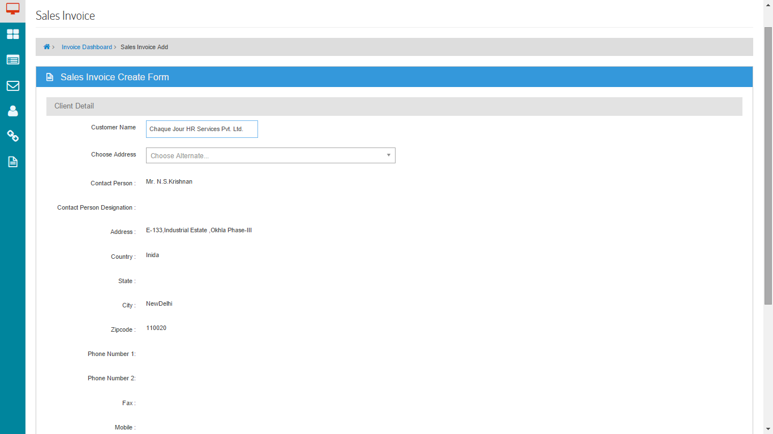

Screen . - Create Invoice (Client Details)

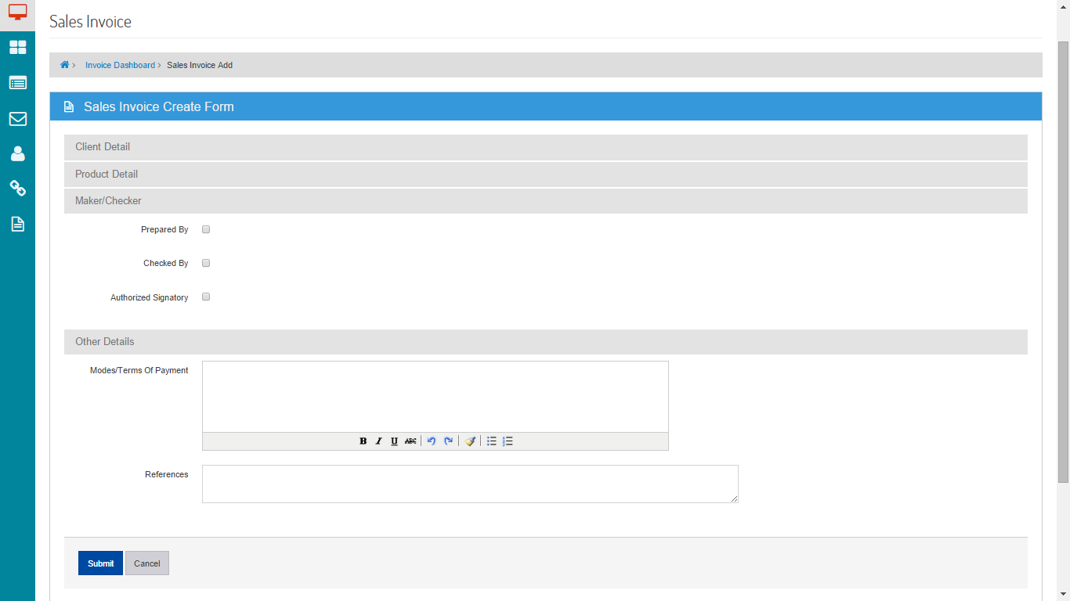

Screen . - Create an Invoice (Maker / Checker Details)

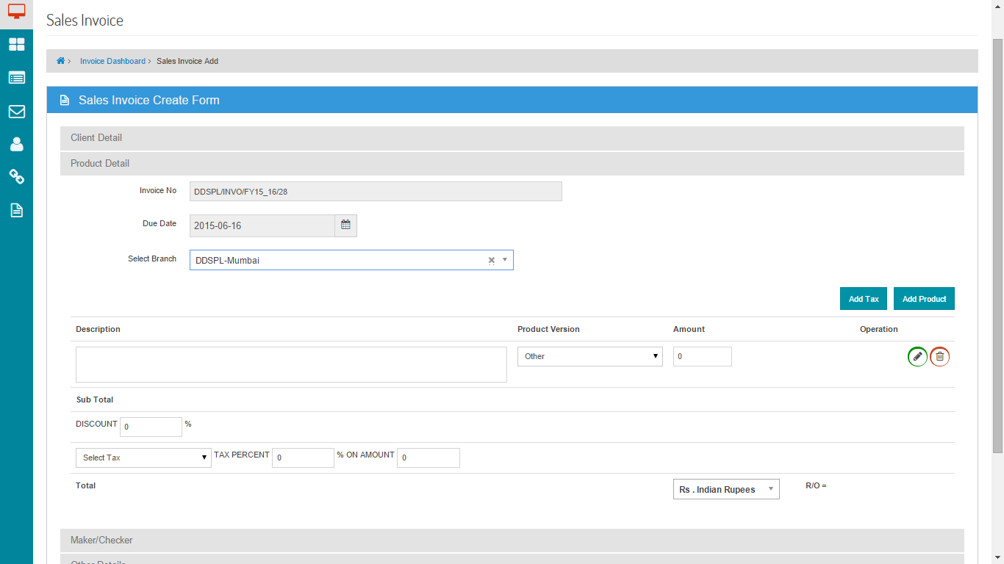

Screen . - Create an Invoice (Product Details)

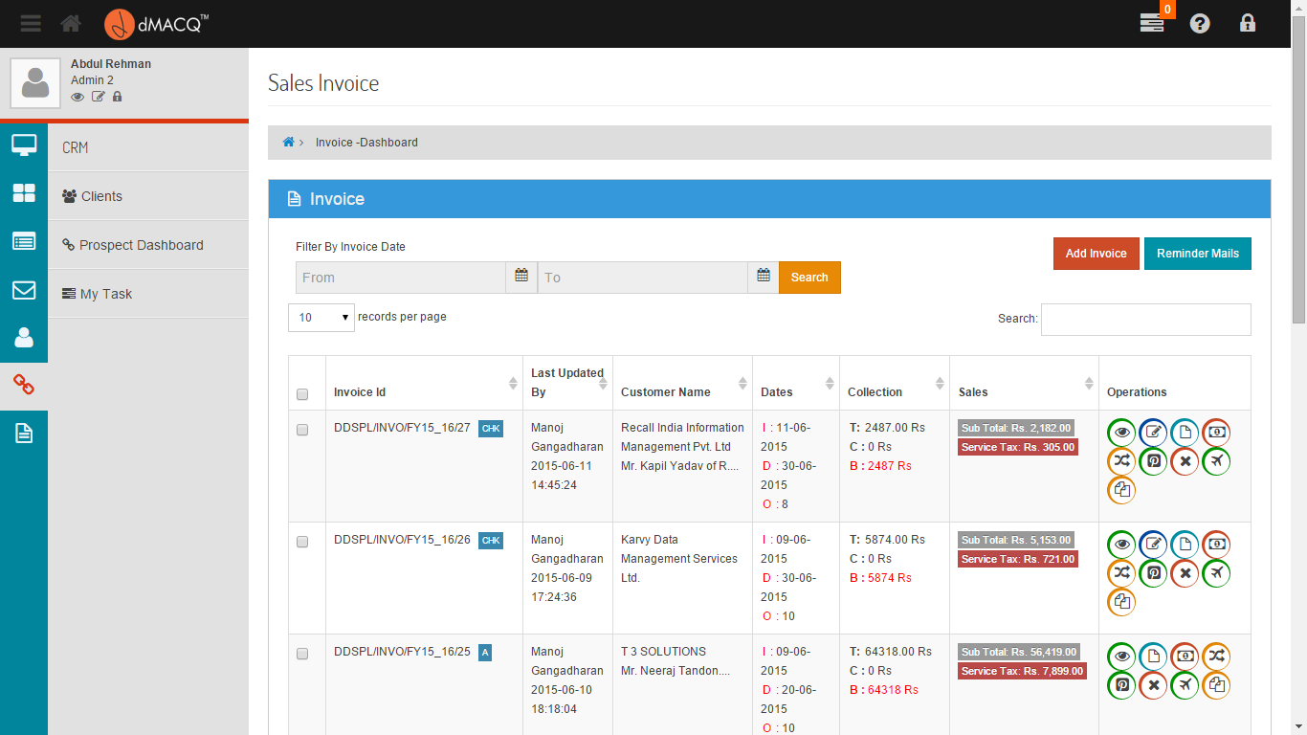

Screen . - Sales Invoice Dashboard

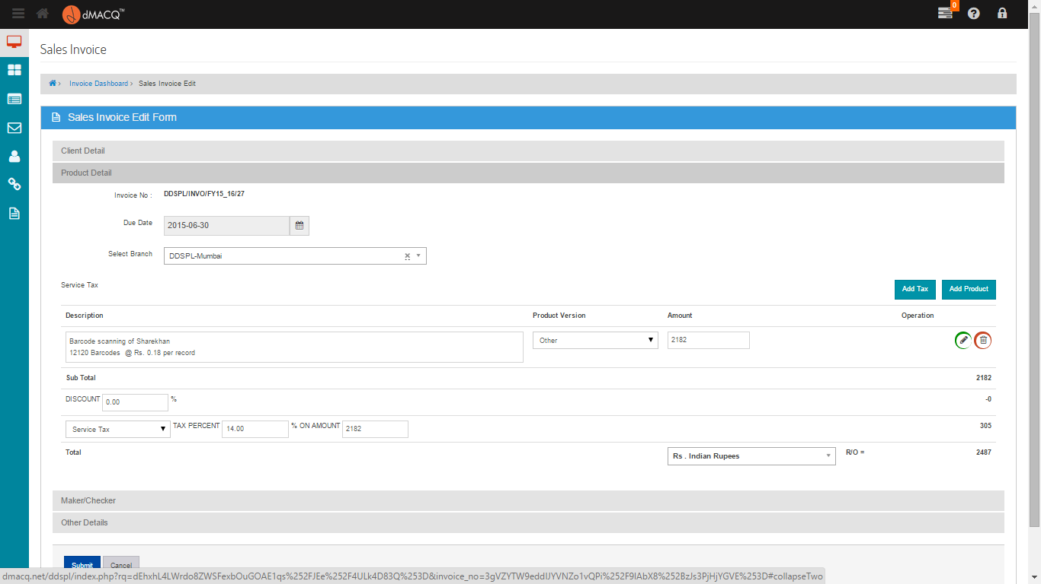

Screen . - Edit an Invoice

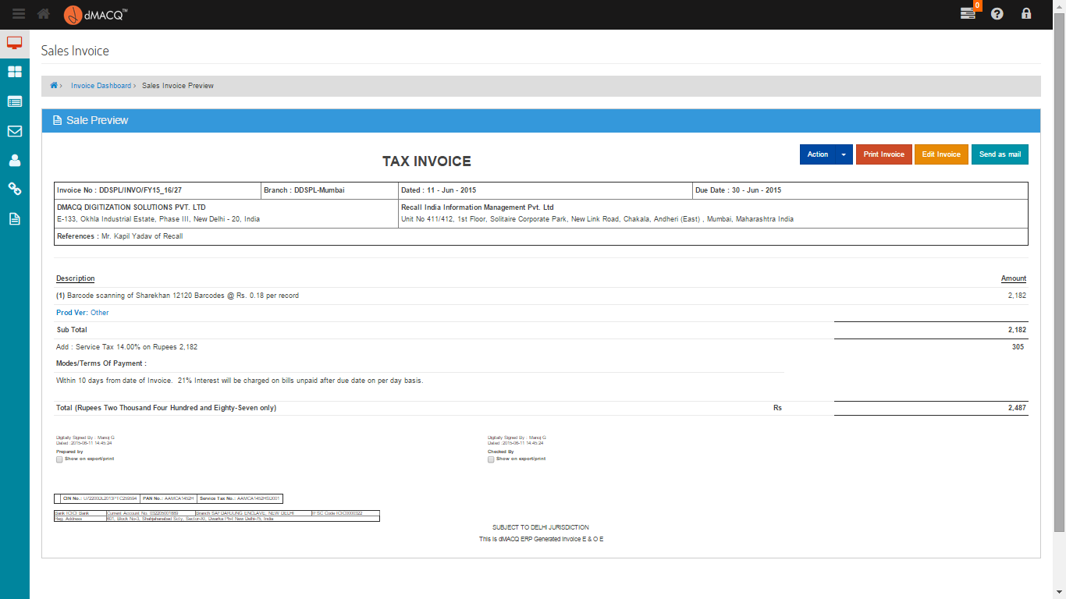

Screen . - View an Invoice

# CONCLUSION

This project has been designed with our utmost capabilities and efforts.

It has been tested for all possible acceptation keeping in mind, the primary requirement of ‘building a robust system’.

This experience has enriched our knowledge of developing a web application and has proved to be the stepping stone in our career.

Also this project gives us a lot of knowledge about the booking concept which definitely will help us in our career

# FUTURE ENHANCEMENT

We believe in one line “There is always an inch more to build”.

This means, our system can be enhanced, and will be enhanced further more.

We were bound by certain criteria such as time, money, syllabus permission like professional talent and work experience.

But positively, without these bounding criteria, we would like to enhance this software project and empower it with many more functionalities.

Some functionalities in our future enhancement includes.

* Inclusion of stringent security.
* Integration with the advanced web.
* Performance and code optimizations
* Bulk Indexing
* Bulk Upload
* Multiple Indexing

Our current project is a sincere effort to balance all the current limiting criteria but we hope that we can add above functionalities to our current project.

# REFERENCES

[1] Project guidelines and coding styles as documented by dMACQ Software Pvt. Ltd.

[2] dMACQ Document Management System, 2008

[3] GoDaddy Web Hosting Services an all its affiliated partners in the domain “dmacq.net” and its webmail services.

[4] Tesseract OCR Engine, Leptonica, Google Code Inc.

[5] Ghost Script, Artifex Software Inc.

[6] PDFTK, PDF Labs

# BIBLIOGRAPHY

[1] Aman Sharma, *DOCUMENT MANAGEMENT SYSTEM,* A Paper Submitted to the Graduate Faculty of the North Dakota State University of Agriculture and Applied Science.

[2] Aurelia Pătraşcu, *Document Management Processes and Use Case Scenarios Elaboration,* Faculty of Economic Sciences, Petroleum-Gas University of Ploieşti, Romania.

[3] Smart Draw 2013, www.smartdraw.com